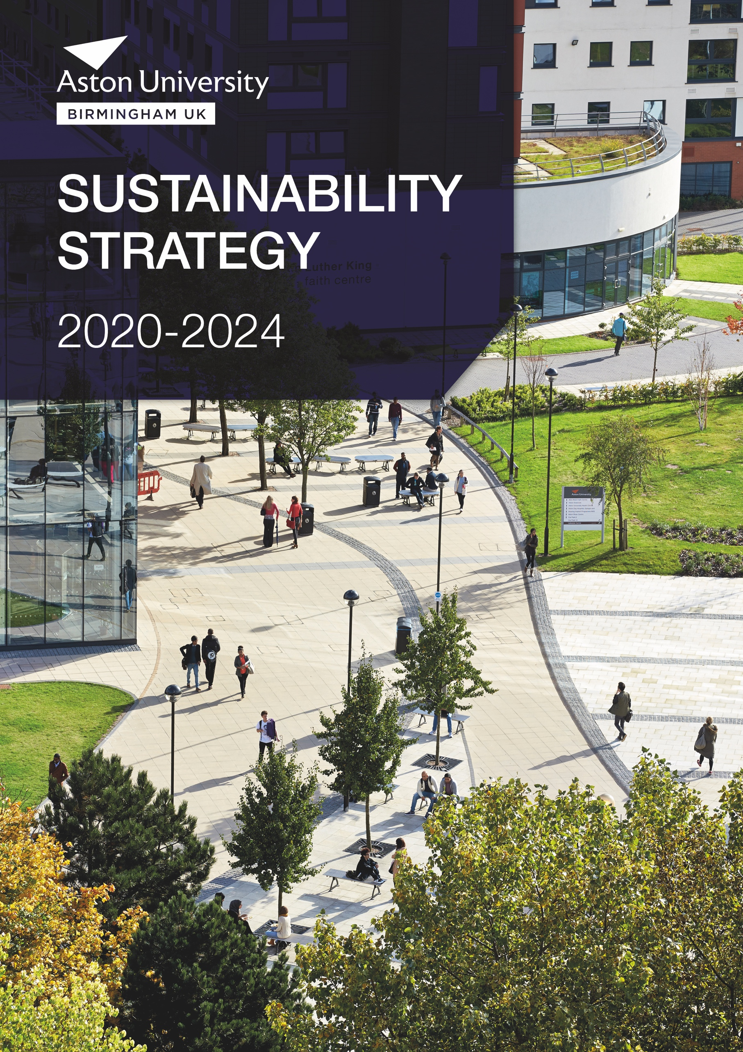
Vice-Chancellor’s introduction
The development and articulation of Aston University’s sustainability strategy gives us the opportunity to communicate clearly our ambition, our objectives, and our priorities; to state what is most important to us, and to identify our points of distinction.

As presented in the Aston Strategy 2018 to 2023, the University will support its three beneficiaries:
- our students, who progress to be our graduates and alumni;
- business and the professions, who employ our students, and also engage with us directly on research and educational programmes;
- our region and society, whom we serve as a public university, with a strong sense of place.
Aston University strives to have a positive impact on all our beneficiaries, making economic, social, environmental and cultural responsibilities a priority, alongside our commitment to education and research excellence.
PROFESSOR ALEC CAMERON
Vice-Chancellor
Our aim is to embed sustainability throughout our working practices, as well as integrate it into student education, research and our highly professional support services.
This sustainability strategy is the next phase of promoting sustainability at the University and has been written in line with the wider University Strategy.
As Vice-Chancellor I will ensure that sustainability remains a central consideration in our decision-making as we work hard to be the best we can be.
There are over ten thousand people at Aston University and every one of us has a part to play in building a sustainable future.

Aston University’s Mission, vision and values
In line with the University’s overall mission, vision and values mentioned below, Aston University has produced a sustainability vision to support these.
University’s Overall Vision
In 2023 Aston will have an international reputation for delivery of outstanding graduate outcomes and equipping business and communities with the skills for future success.
University’s Overall Mission
To be the UK’s leading university for students aspiring to succeed in business and the professions, where original research, enterprise and inspiring teaching deliver local and global impact.

University Values
Aston is professional and ambitious:
The University believes this is a prerequisite to realise our mission and vision, and will be recognised by businesses and external organisations as shared values which make Aston an attractive partner for research and education.

Aston is innovative and collaborative:
The University works across disciplines, institutions and partners to be proactive in creating and implementing new ideas, to be a leader in modern educational techniques and to undertake research which inspires staff, students and external partners.

Aston is ethical and inclusive:
The University recognises its responsibility to be an exemplar of behaviour and conduct in all that it does. It will leverage the diversity of its staff and student body to achieve outcomes for its beneficiaries and provide opportunities for education and professional development to all.

Sustainability Vision
The University will strive to embed sustainability and social responsibility into all its practices in order to aid its three main beneficiaries. All of our students and staff will get the opportunity to integrate sustainable values into their daily activities now and in the future to improve theirs and the University’s local and global impact.

Defining Sustainability
Sustainability is about equity: a sustainable society is one in which there is equitable access to the Earth’s resources both within and across generations. A sustainable organisation acts not only to ensure its own success, but also to benefit the wider community and maintain a natural, healthy environment.
Sustainability-related issues such as: natural resource scarcity, energy security and climate change, population growth, poverty and human health; may impact our core beneficiaries.
Sustainable Development Goals (SDGs)

As well as improving sustainability within Aston University, we are also concerned about the wider social and economic impacts the university has on the world. As such, we are focusing on Aston’s contribution to achieving the United Nation’s Sustainable Development Goals (SDGs). These seventeen goals have been agreed by world leaders, after extended consultation with a host of people and organisations, to drive the global agenda to create a better world through to 2030.
SDGs to support the global effort to make a better world by 2030, and to publicise the University’s widespread contribution to society in Birmingham, in the UK, and the world at large.
Although this strategy focuses on environmental sustainability and social responsibility and the SDG’s that surround these topics, there are other University strategies or policies that support the remaining SDG’s. For example Aston’s work on Athena Swan helps to support SDG 5: Gender Equality and SDG 10: Reduced Inequality.


Objective 1
Sustainable Campus
Objective outline:
To conserve the planet’s resources, reducing the impact of the University campus and its operational activities.
Strategy
We commit to:
- Continually improving our ISO 14001 (Environmental Management System) and ISO 50001 (Energy Management System)
- Reduce our carbon emissions and energy consumption through the development and implementation of a strategic carbon management plan;
- Reduce our water usage in line with University targets;
- Reduce waste sent to landfill and increase our recycling initiatives, including reducing our single sourced materials such as plastics. The University will look to implement the waste hierarchy throughout all its procedures working with our key suppliers.
- Enhance biodiversity throughout campus.
- Develop and promote sustainable travel opportunities.
- Strengthen our resilience against future environmental risks, such as climate change and resource scarcity, by reviewing our existing risk management processes.
- Embed sustainability into our capital projects in line with the SKA Higher Education certification scheme (for refurbishment projects) and the University’s Sustainable Construction Specification (for new buildings).
This is supported by:
- Our objectives and targets reviewed annually through our ISO 14001 and ISO 50001;
- The University’s Sustainability Policy, Energy Policy and other code of practices around sustainability that the University reviews annually; and
- Our Biodiversity Guidelines and Transport Strategy, which are also reviewed annually.





Goals focused on:

Objective 2
Sustainable Communities
Objective outline:
To engage with the wider community to embed sustainability. The University will look to develop partnerships with regional, national and international stakeholders in order to be a positive partner in society.
Strategy
We commit to:
- Work with external regional groups such as The West Midlands Climate Action taskforce (WMCA) and Sustainability West Midlands (SWM) to support region carbon targets and other sustainable initiatives.
- Communicate our sustainability aspirations to our international partners.
- Work with the Students’ Union strategically to embed sustainability into their organisation including student societies and other bodies to support students becoming responsible citizens and an active part of society, both locally and globally.
- Work with internal staff and student groups such as AstBUG, Aston Wildlife group and the Canal Adoption group to support their activities.
- Embed sustainability into our procurement and financial practices, enhancing our supplier engagement.
This is supported by:
- International Team to promote the strategy with our international community and partners;
- Students’ Union and their work on Green Impact and links to clubs and societies;
- Supporting established networks such as regional Environmental Associations for Universities and Colleges (EAUC) networks, Sustainable West Midlands, Birmingham Anchor Network and Active Wellbeing Society;
- Working with local businesses through activity undertaken by the Research Knowledge Exchange (RKE) team and Low Carbon SME project (based in Aston Business School); and
- Our work on the Flexible Framework and our supplier engagement tool NetPositive.





Goals focused on:

Objective 3
Sustainable Development in Academic Activities
Objective outline:
Aston will look to integrate sustainable values and social responsibility into both formal and informal curriculum for all students and staff. It will also support and promote research related to sustainability.
Strategy
We commit to:
- Integrate sustainable development at school programme level.
- Make explicit the links between a student’s sustainability literacy and high quality learning and teaching, student engagement, employability and entrepreneurship.
- Supporting the research and engagement work implemented through the Energy and Bioproducts Research Institute (EBRI).
- Engage research staff and students to consider how their research could impact upon the wider sustainability agenda and Aston University’s goals.
- Support the University’s wider employability objectives and create opportunities for students to engage in sustainability activities.
- Provide ‘living laboratory’ opportunities for final year projects.
- Equip staff with sustainable skills to bring about change in their role and department as part of wider staff development.
- Actively showcase and promote good practice including the communication of research activity to our beneficiaries.
- Make teaching and research practices sustainable.
This will be supported through our work on:
- The NUS’s Responsible Futures accreditation;
- Graduate Attributes - working with Centre for Learning Innovation & Professional Practice (CLIPP) and Careers and Placements to make sustainability a Graduate Attribute; and
- Estate and Capital Development initiatives that can support student final year projects.
The Living Laboratory concept is about enhancing the value of the estate, student education and innovation by using the campus as the site for teaching, research and discovery. This concept can be taken outside the campus and support regional organisations.


Goals focused on:

Ownership for each objective
Although everyone at Aston University needs to support this strategy, the overall responsibility of achieving each objective will sit with a number of key senior staff. The following people will lead on each objective.
Objective 1 - Sustainable Campus
The first objective will sit within the Estates and Capital Development (ECD), led by the Director of Estates. Within ECD sits the Sustainability Team that will work on the key commitments described within Objective 1. This objective will be supported by a number of other departments such as HR and Catering.
Objective 2 – Sustainable Communities
The second objective will be supported by a number of colleagues from different departments including members from the International Office, Human Resources, Business Engagement, Finance and the Students’ Union.
The wider remit around Corporate Social Responsibility (CSR) will be lead through the University’s Engagement Strategy.
Objective 3 - Sustainable Development in Academic Activities
The third objective will be led by the Pro-Vice-Chancellor (Education), with input and support from across the Colleges and central services, including RKE, Education Team and Careers and Placements.


Indicators of achievement
The following will be the key indicators of the strategy working effectively during its lifetime:
- Relevant action plans are implemented and audited with clear and simple guidelines available for staff and students. This includes policies that are reviewed and aligned with the University’s Strategy.
- Internal standards are part of a systematic process that includes maintaining our ISO 14001 and ISO 50001 management systems.
- All staff understand what sustainability is and how this relates to the core business of the University.
- Aston University is supporting Birmingham’s desire to be zero carbon by 2030.
- There is improved sustainability knowledge of our supply chain. Sustainability and Corporate Social Responsibility will be a core part of our contracts and tendering process.
- The University has gained the National Union of Students (NUS) Responsible Futures accreditation and annually audits its progress, working with the Students’ Union.
- A Living Lab concept is in place and visible throughout student projects. Research activity is understood and communicated regularly.
- Communication of best practices and project outcomes is common practice. The student and staff forum is a vibrant space for sharing ideas.
- All students have the opportunity to study and be involved in sustainability. Students understand how their experiences translate into employable skills. Sustainability is a Graduate.
- Sustainable Development workshops support the PG Cert programme giving academic staff the opportunity to embed sustainability and corporate responsibility within their modules.
- Third sector organisations are being supported to develop knowledge and capacity. We have open and two-way discussions with key stakeholders in the City of Birmingham to create positive, socially sound opportunities.
- We are a leader in sustainability, and this is one of the reasons why visitors are attracted to Aston University.
- There is a significant reduction of all our waste levels, with the University and suppliers implementing reusable packaging schemes.
- We are an exemplar of biodiversity planting in an urban setting. We are an open and inviting campus for people to explore urban biodiversity.
- Increased levels of sustainable travel undertaken by staff and students.

Keeping us on track
This sustainability strategy is just one step towards embedding sustainability across the whole University. To make sure it remains relevant and ambitious, we have a system of governance and accountability. This includes:
- Progress will be measured on a continuous basis by the Sustainable Aston Working Group;
- We will regularly monitor our progress by publishing our annual sustainability report, which will be available to a wider external audience. A summary of which will be presented to the University’s Executive Team;
- Departments and schools will be supported by the Sustainability Team to embed sustainability into their core business;
- Our students are key to the success of our sustainability strategy. This is why we’ll ensure that we work closely with our Students’ Union and student clubs and societies.
- This sustainability strategy has several supporting policies and action plans that both impact and underpin its aims. These will be reviewed periodically, with any changes reported to the Sustainable Aston Working Group.
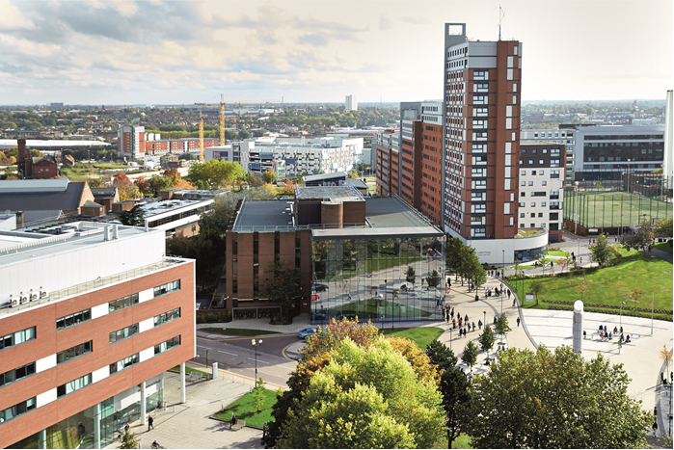

Our Commitments
We have made a number of commitments to work towards a sustainable future for Aston University.
A list of our key policies and documents that will help achieve the targets we set is below.

University’s Overall Vision
In 2023 Aston will have an international reputation for delivery of outstanding graduate outcomes and equipping business and communities with the skills for future success. (University owned)

Strategy
- Sustainability Strategy (University owned)
- Campus Vision and Master Plan (Estates and Capital Development owned)
- Carbon Management Plan (Estates and Capital Development owned)
- Food Action Plan (Catering@Aston owned)
- Transport Strategy – currently in draft form (Estates and Capital Development owned)

Policy, guidelines and other documentation
- Biodiversity Code of Practice (Estates and Capital Development owned)
- Biodiversity Guidelines (Estates and Capital Development owned)
- Energy and Water Policy (Estates and Capital Development owned)
- Environment and Sustainability Policy (Estates and Capital Development owned)
- Ethical Investment Policy (Finance Team owned)
- Sustainable Food Code of Practice (Catering@Aston owned)
- Sustainable Procurement Code of Practice (Procurement Team owned)
- Waste Management Code of Practice (Estates and Capital Development owned)
- Sustainable Construction Specification (Estates and Capital Development owned)
- Adaption and Climate Change at Aston (Estates and Capital Development owned)

Management Systems
- Environmental Management System - ISO 14001:2015 standard (University owned)
- Energy Management System - ISO 50001:2018 standard (University owned)
- Environmental Management System - Eco-Campus (University owned)



