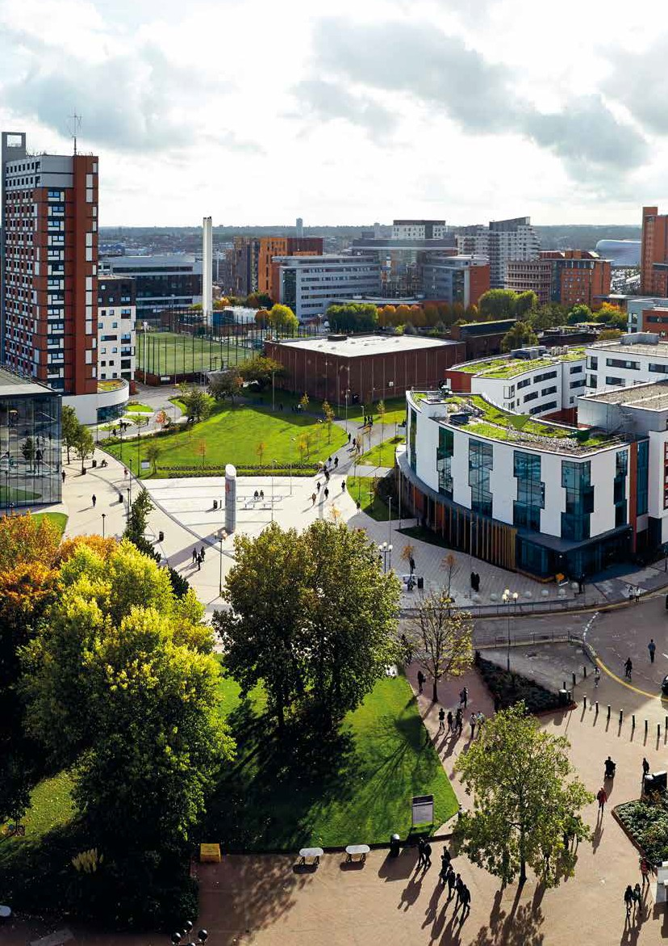

TRANSPORT
STRATEGY

© Aston University

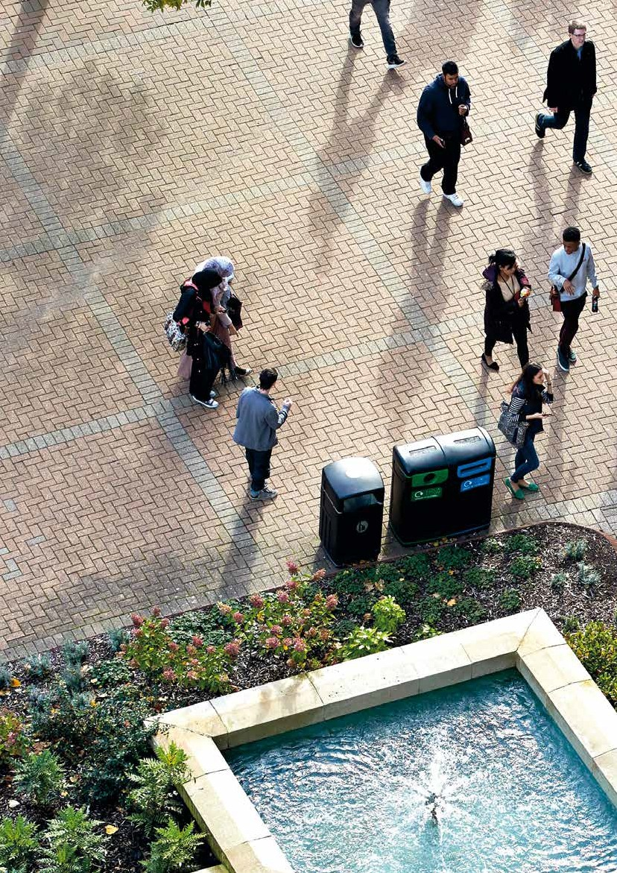CONTENTS
- INTRODUCTION
  - Our vision

TRANSPORT CONTEXT
  - Strategic context
  - City context
  - Cycle network
  - Stations
  - Public transport accessibility
  - Summary

TRAVEL BEHAVIOUR
  - Current travel behaviour
  - Public transport accessibility for staff
  - Car parking
  - Summary

DRIVERS FOR CHANGE
  - Introduction
  - Drivers for change - part one
  - Drivers for change - part two

TRANSPORT STRATEGY
  - Introduction
  - Transport strategy summary
  - Transport strategy summary - spatial plan
  - Making the shift
  - Building it in
  - Changing the context
  - Brave new world

2

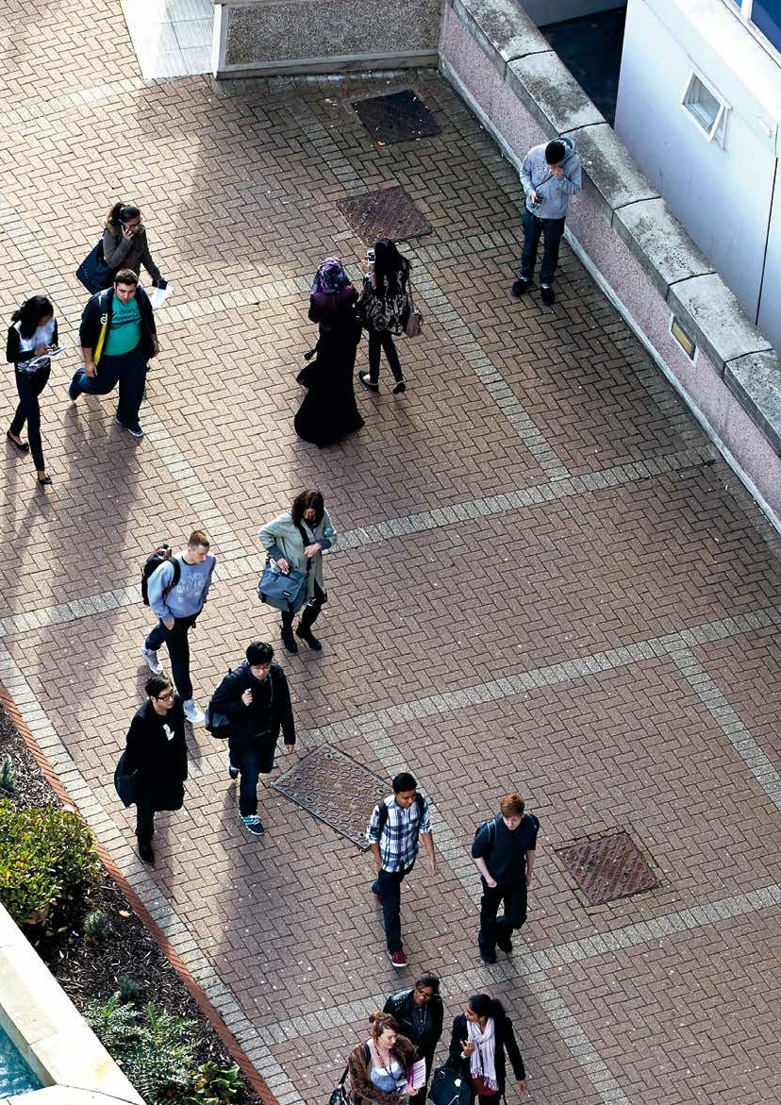

3

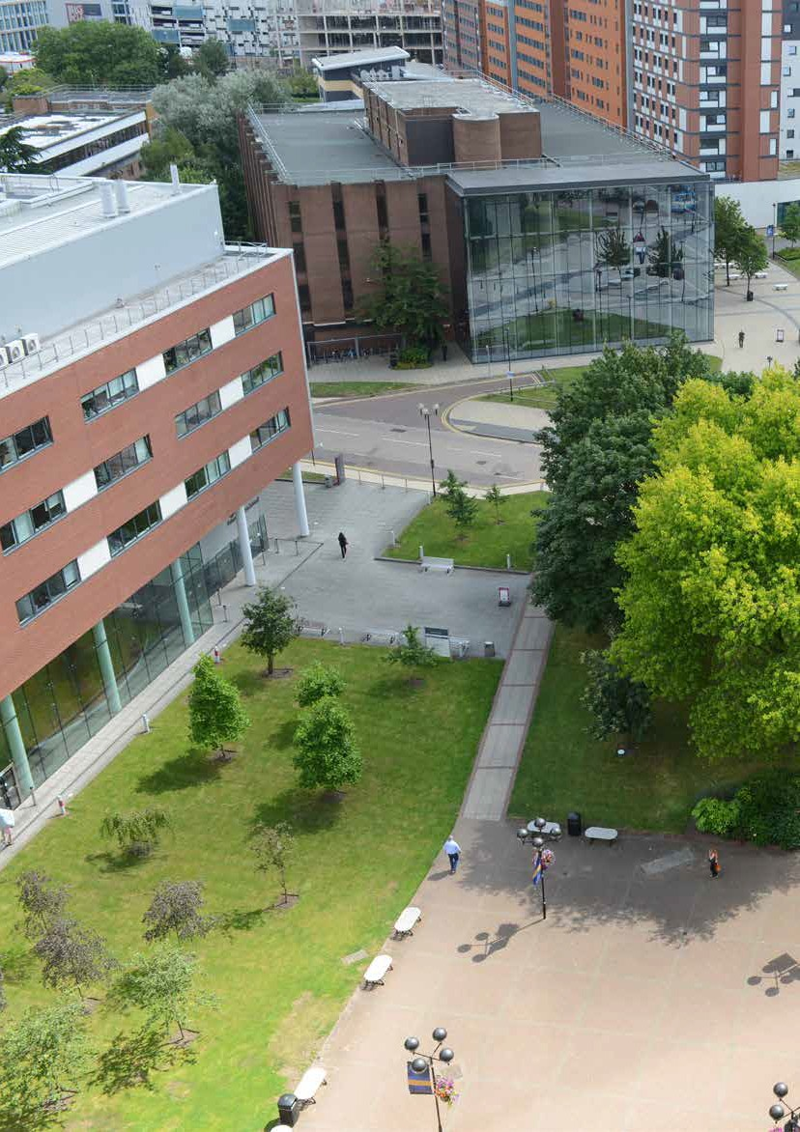INTRODUCTION

4

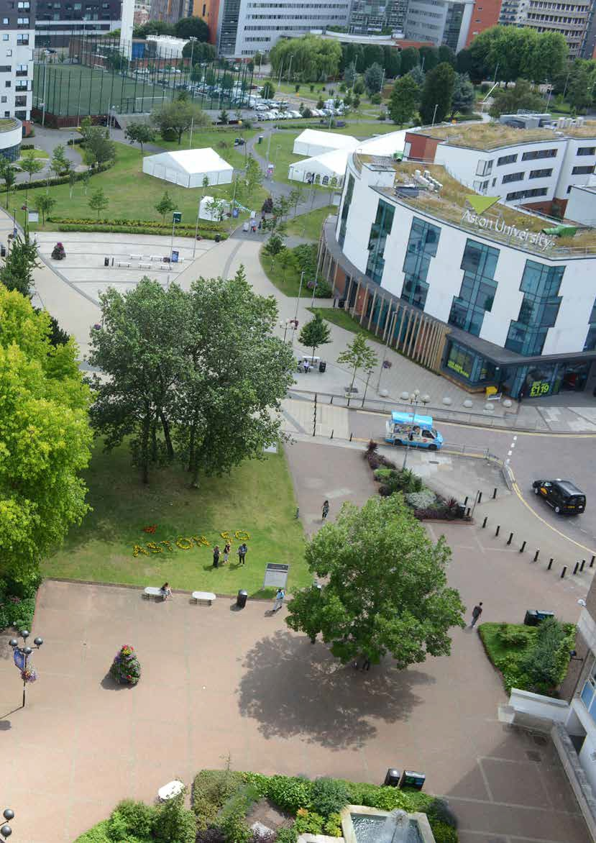

5

INTRODUCTION

OUR VISION

Birmingham is undergoing a period of unprecedented and transformational change. Aston University has a critical role to play in not only the development of the Knowledge Quarter, but also the city and the wider region.
An ambitious Campus Vision and Masterplan have been developed for the University to create a campus that will help it fulfil this role and offer an outstanding experience for its beneficiaries, which include:
- Students, who progress to be graduates and alumni.
- External organisations (businesses, public entities and the not-for-profit sector), who employ graduates and students and engage with the University on research and educational programmes.
- Birmingham and the West Midlands Region, wider society who the University serves, as well as a public university with a strong sense of place.
This Transport Strategy supports the delivery of the Campus Vision and Masterplan and also identifies transport and public realm investment actions beyond the University. These are actions needed by others to support the development of Aston University and the wider Knowledge Quarter to enable them to play their full role in the ongoing transformational change of Birmingham and the wider region.
The strategy also recognises and responds to a set of wider ‘drivers for change’, which mean
that ‘business as usual’ in relation to transport is unsustainable. These drivers mean that there is a critical need to reduce car use and increase the use of active, sustainable, shared and efficient modes of transport. These overarching drivers for change can be summarised as follows:
- Climate change.
- Environmental concerns, such as air quality and noise pollution.
- Growth and development of the city, leading to increasing travel demand.
- The need to enhance the city centre as a destination and place to invest.
- The need to improve the liveability of the city and the health and wellbeing of its residents.
- The need to improve the accessibility and equity of transport.
The strategy also identifies specific policy and masterplan changes within the city centre, which will directly impact on the University and its approach
to transport. These include the Clean Air Zone (CAZ), which is to be implemented in summer 2020 and which the University sits within. In terms of masterplanning, there are several masterplans that will change areas directly adjacent to the University. The most significant of these is the Curzon area masterplan, which responds to the proposals for HS2.
The strategy also addresses a number of issues that have been identified as being important to the University including:
- Seeking to ensure travel to the University is not a barrier to accessing education or employment.
- The provision of car parking on campus.
- Continuing the shift towards sustainable transport for staff, students and visitors.
- Enhancing the public realm and experience of spending time on campus.
- Improving connections to the wider city centre and links to public transport.
- Ensuring the University understands and can plan for key transport trends and drivers for change.
In response to these drivers, city centre changes and the ambitious proposals for the University campus, the Transport Strategy has four strands, which are briefly described below.

6

MAKING THE SHIFT
This strand recognises the need to ensure that most travel to and from the University is undertaken by active, sustainable, shared and
efficient modes of transport. A key component of this will be the continuing development
of ‘soft‘ measures, which encourage the use of sustainable modes of transport
through marketing, incentivisation and policy development. A key element of this will be the development of a more focussed approach to the granting of staff parking permits.
CHANGING THE CONTEXT
The University campus is part of the city centre and within walking distance of the main train stations and bus interchange. However, the walking and cycling environments are often unattractive and significant severance is caused by the highways between the campus and the rest of the city centre.
There are also limitations on the locations one can access by bus, which stop adjacent to the site.
These issues cannot be directly addressed by the University and therefore, working with
Birmingham City Council (BCC) and Transport for West Midlands (TfWM) is going to be very important. This is to ensure that the University is better integrated for walking and cycling with the surrounding city, connections to the stations are direct and high quality, and the University is served by high frequency
and high quality public transport.

BUILDING IT IN
This strand aims to ensure that the campus layout, public realm and facilities encourage and prioritise the use of sustainable modes of transport, and that all new buildings contain the appropriate shower and locker facilities people need. It addresses issues that are within the University’s control.
This strand also addresses the proposed approach to car parking provision for visitors, the public, staff and students to ensure the levels of parking are consistent with the proposed continuing shift towards active, sustainable, shared, cost effective and efficient modes of transport.
BRAVE NEW WORLD
Ensuring that the benefits of new transport technologies and information are captured and used for the benefit of the University, and particularly its students and staff, is important.
It is also important that the University are aware of preparing for changing and
disruptive transport technologies, as far as they need to and as far as it is possible.
This Transport Strategy identifies some key known trends and actions that can be taken. It will, however, be important to keep a general watching brief on the changing transport market.

7

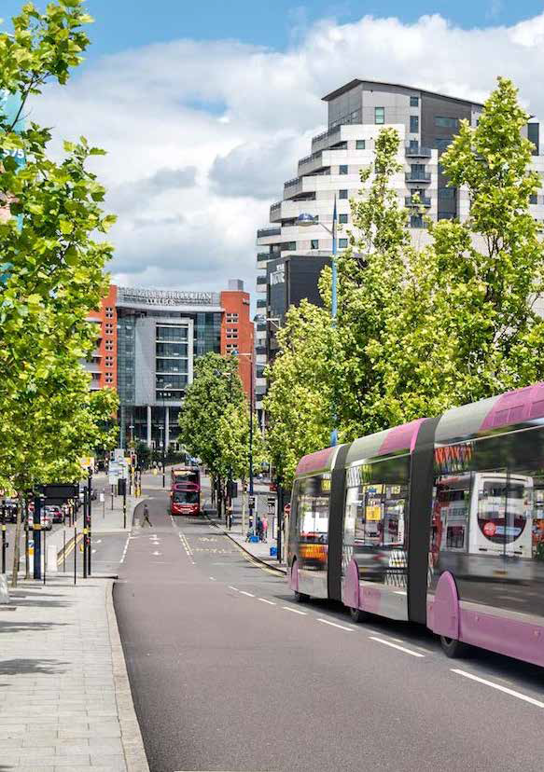TRANSPORT CONTEXT

8

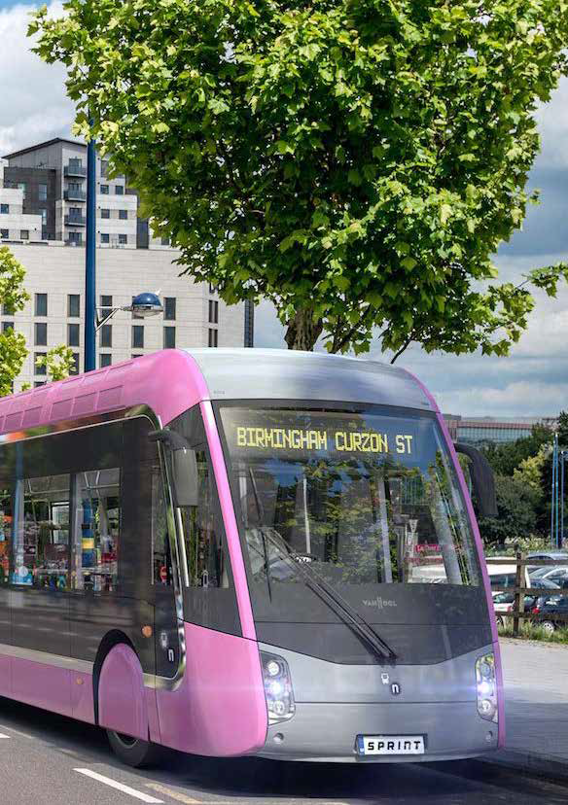

9

TRANSPORT CONTEXT

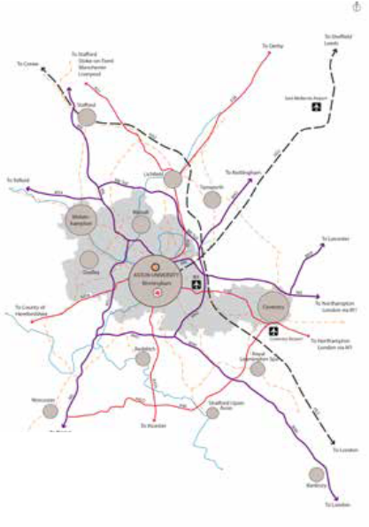STRATEGIC CONTEXT

West Midlands Motorways
A roads HS2
Rail lines
National cycleways
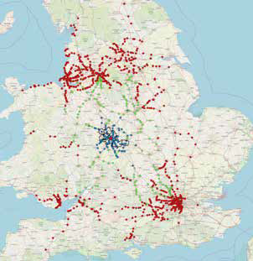
Aston University
Travel time to Aston University (hours) 0 - 1
1 - 2
2 - 3

Birmingham is at the heart of the UK’s strategic road and rail networks. Most of the UK’s rail stations are within three hours’ travel time of Birmingham‘s city centre.
Aston University sits within Birmingham city centre and, therefore, benefits from these strategic road and rail connections. It also benefits from easy access to Birmingham Airport.
Proposals for significantly improving rail and road connections are currently being developed through the HS2 and Midlands Connect projects.

HS2
HS2 will provide significantly quicker connections by rail between Birmingham and London (phase
1) and Manchester/Leeds (phase 2). Anticipated improvements in journey times are listed below.
- Manchester – HS2 time 40 minutes, current time 88 minutes.
- London – HS2 time 45 minutes, current time 82 minutes.
- Sheffield – HS2 time 49 minutes, current time 63 minutes.
- Leeds – HS2 time 49 minutes, current time 118 minutes.
- Newcastle – HS2 time 118 minutes, current time 172 minutes.
- Edinburgh – HS2 time 191 minutes, current time 237 minutes.
- Glasgow – HS2 time 200 minutes, current time 224 minutes.

Midlands connect
Midlands Connect is a pan-Midlands partnership of local transport authorities, local enterprise partnerships and local business representatives working to deliver improved journey times between city centres within the Midlands.
Midlands Connect will also further extend the area of the country within one, two and three hours’ travel time of Aston University.

10

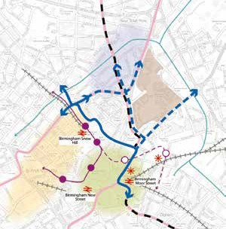
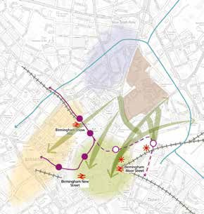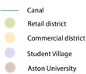CITY CONTEXT

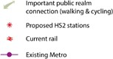
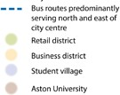
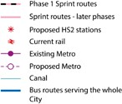
Metro, Sprint and cross-city buses
Within the city centre, Aston University is close to both existing rail stations and proposed HS2 stations.
The existing Metro is within walking distance and the extension proposed to serve HS2 will bring Metro services closer to the campus.
This Metro extension will later be continued to Digbeth and eventually Solihull.
The proposed Sprint routes that will eventually extend through the city centre will run adjacent to the University campus along James Watt Queensway with a bus/Sprint interchange adjacent to the main campus access on James Watt Queensway.
Access to high frequency bus services, which serve the north of the city, currently run adjacent to the site, with buses serving a wider area a short walk away.
Transport for the West Midlands are working to establish cross-city bus services, which would run along Jennens Road. This would result in bus services serving a larger part of the city available adjacent to the campus.

Access to key city centre locations
The University campus is not only close to transport facilities, but also the retail and commercial areas and a large number of privately owned student residences.
However, as will be described later in more detail, the walking and cycling connections between the campus, the main transport interchanges, retail area, commercial area and student residences are often poor in quality and suffer from severance caused by major roads.
The University campus, therefore, despite its proximity, feels somewhat severed and separate from the rest of the city centre.

11

CYCLE NETWORK
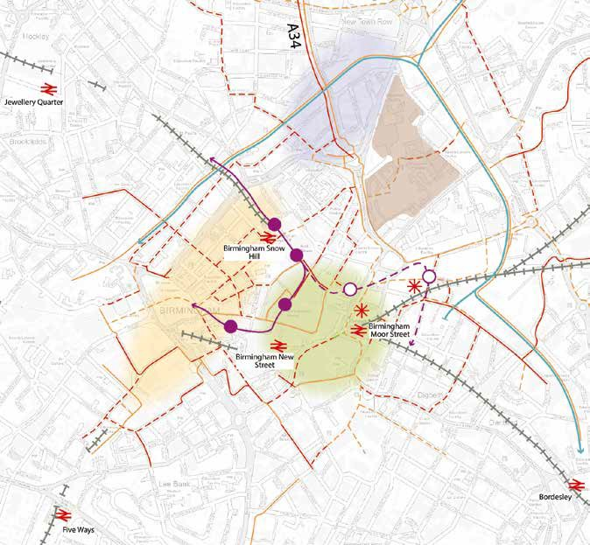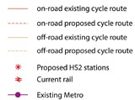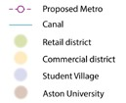

Walking and cycling
Birmingham City Council and TfWM are also investing heavily in transforming the environment for walking and cycling. As shown on the previous page, there are key public realm connections that link the University to important city centre destinations.
As already noted, the quality of these is variable, sometimes poor, and with significant severance. Working to enhance these links will be important for the University both in terms of enabling mode shift, but also because the quality of the city is important for attracting and retaining students and staff, and thus allowing the University to grow.

As well as being close to rail, bus, Metro and Sprint routes, the University also has easy access to existing and future cycle networks.
A first phase of this transformation was the construction of high quality segregated cycle routes along the A34 and A38. The A34 route runs along James Watt Queensway and past the University. At present, these routes are not connected and cycling through the city centre itself is challenging.

12

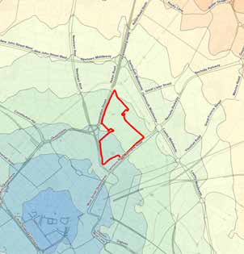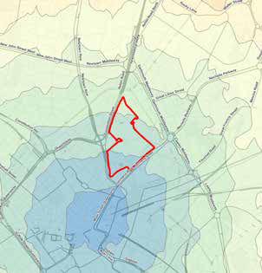STATIONS
NEW STREET
MOOR STREET

Station isochrone |  | Station isochrone
0-400 |  | 0-400
400-800 |  | 400-800
800-1200 |  | 800-1200
1200-1600 |  | 1200-1600
1600-2000 |  | 1600-2000
2000-2400 |  | 2000-2400
2400-2800 |  | 2400-2800
2800-3200 |  | 2800-3200
Estate boundary |  | Estate boundary

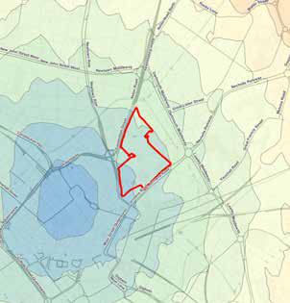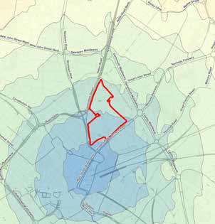
SNOW HILL
Station isochrone
0-400
400-800
800-1200
1200-1600
1600-2000
2000-2400
2400-2800
2800-3200
Estate boundary
HS2 CURZON STREET
Station isochrone
0-400
400-800
800-1200
1200-1600
1600-2000
2000-2400
2400-2800
2800-3200
Estate boundary

Proximity to stations
As noted on the previous pages, Aston University is in very close proximity to both existing rail stations and the future HS2 terminus at Curzon Street.
The isochrones above illustrate how close the University is to the city centre and its transport facilities, most of which are easy to walk or cycle

to. However, as already noted, the quality of the connections is variable and severed by busy roads, which discourages people from walking and cycling to access the wider city centre.

13

PUBLIC TRANSPORT ACCESSIBILITY

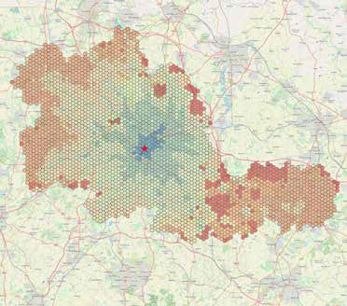Staff Travel time to
WEEKDAY 7AM-9AM
postcodesAston University
(minutes) 0 - 15
15-30
30-45
45-60
60-120
120+
Aston University

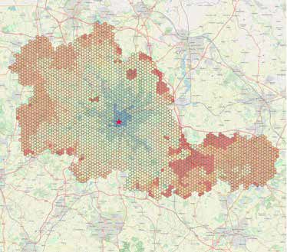Staff Travel time to
WEEKDAY 4PM-6PM
postcodesAston University
(minutes) 0 - 15
15-30
30-45
45-60
60-120
120+
Aston University

Aston University benefits from the city centre’s public transport networks. The plots above (from TRACC) illustrate the journey time to and from the University during the morning and evening peaks, respectively, from postcodes across the West Midlands.
It can be seen that most of the built up areas of the West Midlands are within an hour’s journey time of the University by public transport, both for journeys
to and from the University. It can be anticipated that this pattern of access is similar throughout the day on a weekday, although travel during the evenings and at weekends, particularly on a Sunday, will be more challenging.

14

  - SUMMARY

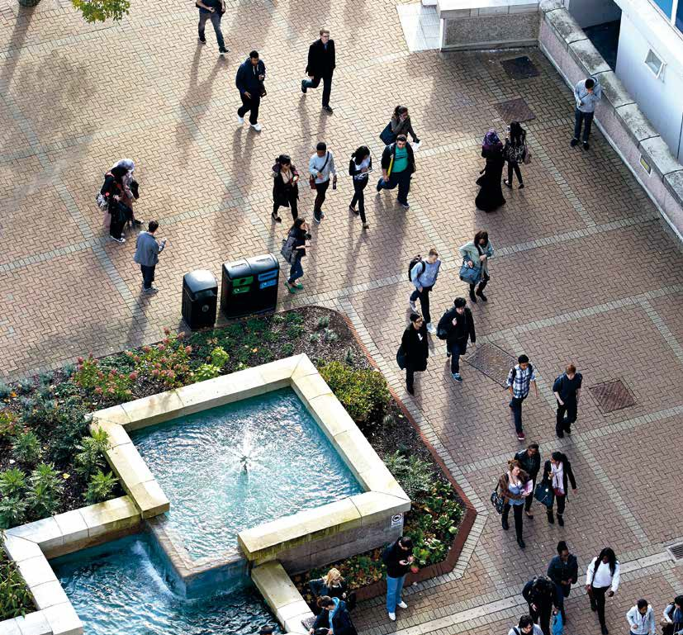Aston University has excellent access by walking, cycling and public transport from across Birmingham as well as the wider West Midlands and UK at-large.
Commuting to the University by public transport is possible within around an hour from most of Birmingham and the urbanised areas of the West Midlands.
Access by rail is also convenient from many locations throughout the country, as a large number of direct rail connections pass through Birmingham city
centre station, all of which are a short walk from the
University.
Considerable investment is planned in transport infrastructure in Birmingham, which will continue to improve access to the University by walking, cycling and public transport.
This continuing investment is important for the University as, although it is very well positioned in relation to the city centre transport networks, the quality of the walking and cycling routes to the University are in some places of poor quality, with significant amounts of severance.

15

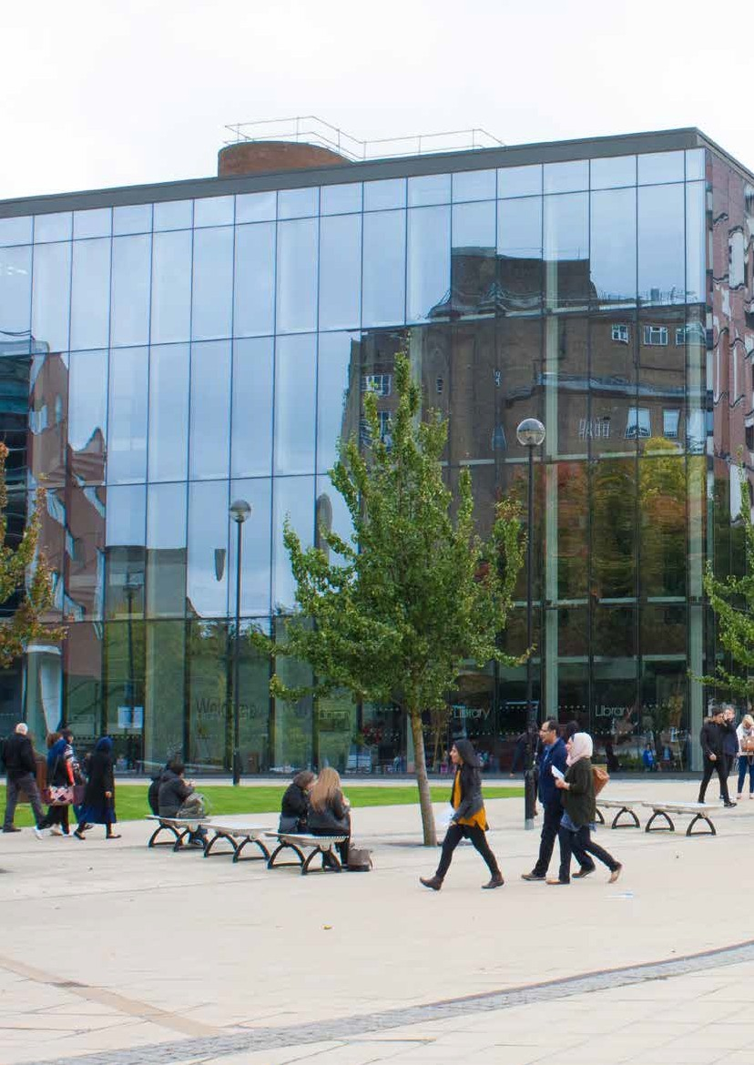TRAVEL BEHAVIOUR

16

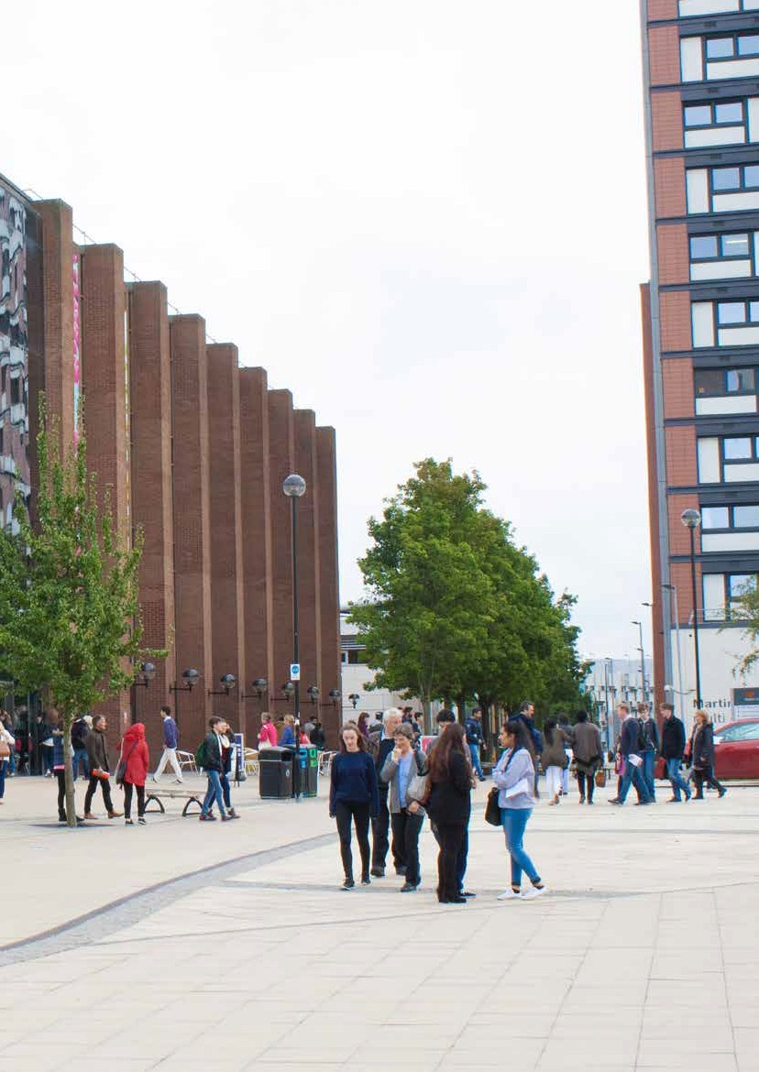

17

TRAVEL BEHAVIOUR

CURRENT TRAVEL BEHAVIOUR
The University has undertaken travel surveys of its staff and students for a number of years, the most recent being in November 2019. These surveys are important to understand trends. The survey in 2019 also asked a series of questions about why people travel the way they do and what would encourage them to change the way they travel. The results are summarised below.

60%

50%

40%

30%

20%

10%

0%
Car

Car share - Car share -

Train

Public bus

Bicy cle

Wa lk

Metro

Park & ride

Cycle to

Taxi

Other

passenger
driver
train/bus station

2005/06 2008/09 2013/14 2015/16 2017/18 2018/19

STAFF TRAVEL BEHAVIOUR

60%

50%

40%

30%

20%

10%

0%
Car Car share - passenger

Car share - driver

Train Public bus Bicy cle Wa lk Metro Park & ride Taxi Other

2005/06 2008/09 2013/14 2015/16 2017/18 2018/19

STUDENT TRAVEL BEHAVIOUR

18

STAFF TRAVEL BEHAVIOUR
The chart below contains a summary of staff travel behaviours. There are a number of key points to note:
    - Walking as a mode share has steadily increased between 2005 and 2019, from around 2% to 10%.
    - The overall trend for cycling has also slowly increased as a mode share between 2005 and 2019, from roughly 3% to 8%.
    - Bus travel has remained fairly stable between 2005 and 2019, with about 15-20% of the mode share during this period.
    - Train travel as a mode share has remained between around 25-30%, although with a dip in 2017/18.
    - Car as a mode share has fallen dramatically, from around 54% in 2005/06 to 21% in 2018/19.
Staff were also asked about their travel behaviour to the University. The top three reasons they gave to key questions are below:
    - Why do they travel how they travel?
      - Quickest way (30%).
      - Other (childcare, easier/more reliable than public transport) (15%).
      - Cheapest way (13%).
    - If they had changed how they travel in the last two years and why?
      - Moved house (23%).
      - Other (change in circumstances, unreliability of public transport) (22%).
      - Health/Fitness reasons (14%).
    - What would they do if parking at the university was unavailable?
      - Still travel by car but park elsewhere (51%).
      - Use alternative mode of public transport (20%).
      - Leave the university (20%).
    - What would encourage them to cycle more?
      - Safer cycle routes/footpaths (35%).
      - More showers/changing facilities (17%).
      - Improved cycle parking/storage (10%).
    - What would encourage them to use public transport more?
      - Ticket/pass discounts (28%).
      - Increased frequency of bus/rail services (18%.
– Flexible working hours/home working (17%).
STUDENT TRAVEL BEHAVIOUR
The graph below contains a summary of travel behaviour for students. There are a number of key points to note:
    - Walking mode share peaked in 2013/14 at almost 50%, but has since fallen back.
    - Bicycle mode share has stayed low at around 2-3%.
    - Bus mode share decreased between 2013/14 and 2017/18, but increased again in 2018/19.
    - Train mode share has not changed significantly, remaining at about 16%.
    - Car share has seen minor increases from zero to about 2%.
    - Car mode share has decreased significantly, from 19% in 2005/06 to 5% in 2018/19.
Students were also asked similar questions to staff about why they travel to the University, and under what circumstances they would change. The top three reasons they gave to key questions are below:
    - Why do they travel how they travel?
      - Quickest way (41%).
      - Cheapest way (26%).
      - No alternative (14%).
    - If they had changed how they travel in the last two years why?
      - Moved house (36%).
      - Financial reasons (15%).
      - University times changed (13%).
    - What would they do if parking at the university was unavailable?
      - Still travel by car but park elsewhere (51%).
      - Use alternative mode of public transport (21%).
      - Reduce the frequency of visits to the university (21%).
    - What would encourage them to cycle more?
      - Safer cycle routes/footpaths (25%).
      - Assistance with purchase of a bike (15%).
      - Improved cycle parking/storage (12%).
    - What would encourage them to use public transport more?
      - Discounts on public transport ticket/passes (36%).
      - Increased frequency of bus/rail services (17%).
–Safer public transport (11%).

19

PUBLIC TRANSPORT ACCESSIBILITY FOR STAFF
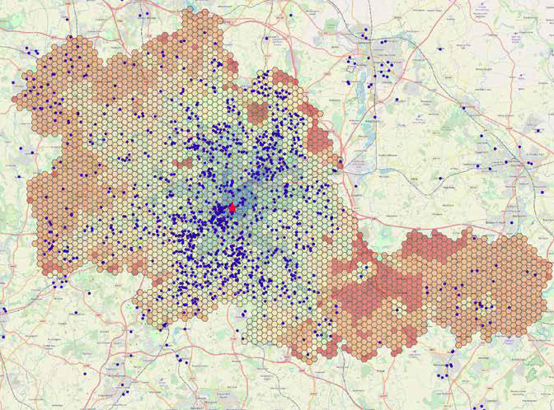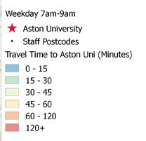
Weekday 7am-9am Aston University Staff postcodes
Travel time from Aston University (minutes)
0 - 15
15 - 30
30 - 45
45 - 60
60 - 120
120+

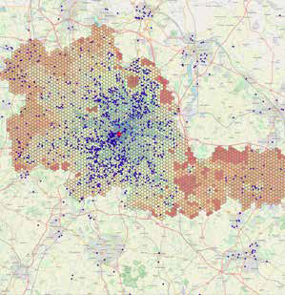
As illustrated on previous pages, Aston University benefits from the public transport networks that serve Birmingham city centre.
On these plans, the home postcodes of current staff have been plotted on the public transport
accessibility TRACC plots. A large proportion of staff live within an hour’s travel time by public transport.

20

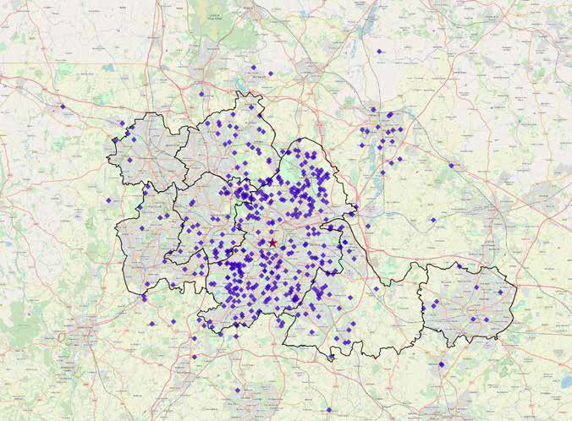

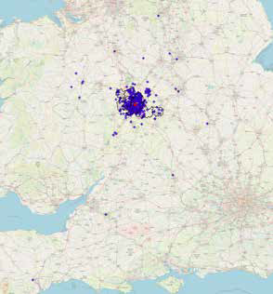
These plots show the home locations of staff with parking permits. Most live within an hour’s travel time of the University by public transport.

21

CAR PARKING

An accumulation survey of car parks within Aston University was undertaken to understand the levels of use, both at different times of the day and on different days of the week.
The car parks that were surveyed included the largest car parks: 3, 5, 6 and 12.
The results of the surveys of car parks 5, 6 and 12 are shown here. Together, these car parks have approximately 506 parking spaces.
Car parks 5 and 6 are both very busy during weekdays and would be classed as being over- capacity in terms of demand. Car park 5 is shown as significantly over-capacity during the week, although it is noted that the informal nature of this car park
makes it difficult to accurately assess the number of available spaces.
Car park 12 is far less well-used, which may be in part due to it being a covered / multistorey car park, but may also be as a result of its location and access.
At the weekend, parking demand was significantly lower. Car parks 5 and 6 were, however, quite busy with car park 6 reaching full capacity in the morning. However, it is worth noting that on the weekend during which the survey was completed, a Christmas Market was operating nearby and likely increased demand for parking in this location. As such, it is also important to consider how car parks at Aston University can play a wider function within the city centre at weekends.

250

200

150
Parking Figures

100

50

0
Car Park 5 - Tues 19th Nov

7:00 8:00 9:00 10:00 11:00 12:00 13:00 14:00 15:00 16:00 17:00 18:00
Time of Day

Parking Data
Total Spaces
90% Capacity

250

200

150
Parking Figures

100

50

0
Car Park 5 - Sat 23rd Nov

7:00 8:00 9:00 10:00 11:00 12:00 13:00 14:00 15:00 16:00 17:00 18:00
Time of Day

Parking Data
90% Capacity
Total Spaces

250

200

150
Parking Figures

100

50

0
Car Park 6 - Tues 19th Nov

7:00 8:00 9:00 10:00 11:00 12:00 13:00 14:00 15:00 16:00 17:00 18:00
Time of Day

Parking Data
Total Parking
90% Capacity

250

200

150
Parking Figures

100

50

0
Car Park 6 - Sat 23rd Nov

7:00 8:00 9:00 10:00 11:00 12:00 13:00 14:00 15:00 16:00 17:00 18:00
Time of Day

Parking Data
Total Parking
90% Capacity

200
180
160
140
Parking Figures
120
100
80
60
40
20
0
Car Park 12 - Tues 19th Nov

7:00 8:00 9:00 10:00 11:00 12:00 13:00 14:00 15:00 16:00 17:00 18:00

Time of Day

Parking Data
Total Parking
90% Capacity

200
180
160
140
Parking Figures
120
100
80
60
40
20
0
Car Park 12 - Sat 23rd Nov

7:00 8:00 9:00 10:00 11:00 12:00 13:00 14:00 15:00 16:00 17:00 18:00

Time of Day

Parking Data
Total Parking
90% Capacity

22

  - SUMMARY

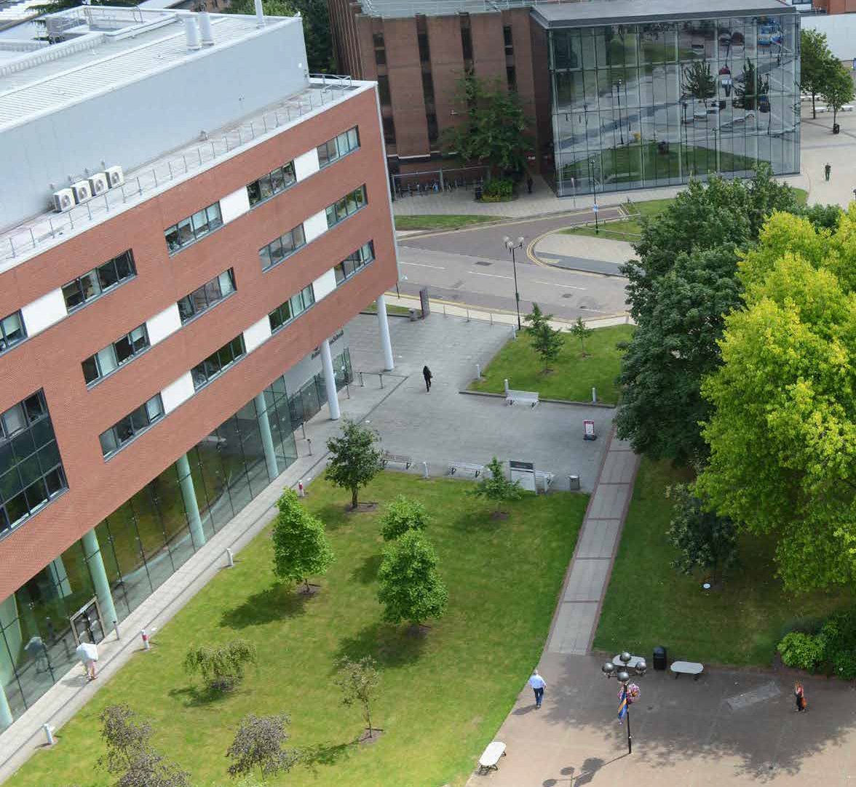As illustrated earlier in this document, Aston University benefits from the public transport networks that serve Birmingham city centre.
The home postcodes of current staff have been plotted on the public transport accessibility (TRACC) plots. This has shown that a large proportion of staff live within an hour’s travel time by public transport.
Staff with parking permits also largely live within a convenient distance by public transport.
From the staff and student survey, it can be seen that there has already been a significant overall reduction in car travel to the University for both students and staff, although this has levelled off over the last year or two.
From the surveys, it is also clear that the cost of public transport and improving the cycle networks that access the site are key issues for increasing the modal share of those modes. Neither of these
issues are directly within the control of the University, but can be influenced through partnership working
with Birmingham City Council, TfWM and the public transport operators.
The survey also indicates that there is also work to do within the University on improving facilities, including cycle parking and showers, as well as through other measures such as flexible working for staff and supporting bike purchases through a cycle to work scheme.
From the car parking survey, it is clear that car parks are well used during the week and are also used at weekends.
The staff and student surveys asked what respondents would do if parking wasn’t available. Most said that they would either park elsewhere (c. 50%) or use an alternative mode of transport (c. 20%). However, a significant proportion of staff drivers who responded said they would leave the University if they couldn’t park. This underlines the need to understand in detail why individuals use the car for work and to support staff both through the changes to city centre access and as parking provision changes over time.

23

DRIVERS FOR CHANGE

24

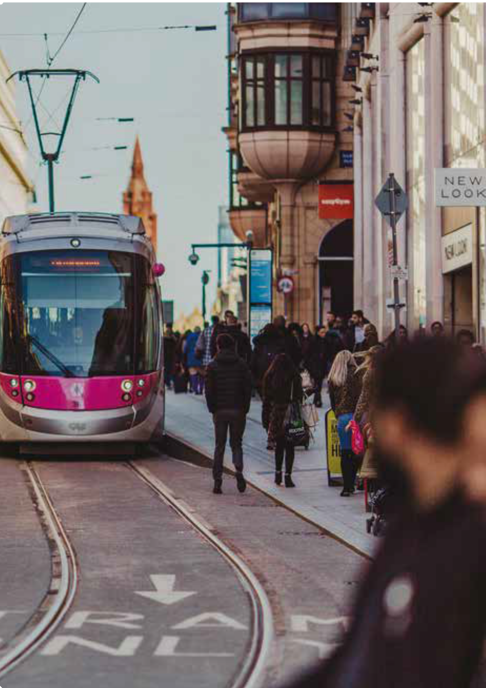

25

DRIVERS FOR CHANGE

INTRODUCTION
Transport, particularly in cities, is changing. There is increasing recognition that the way many people currently move around cities, largely in private cars, has negative impacts.
These negative impacts work at both city and global levels, and this recognition is driving changes to cities’ transport strategies and investment programmes.
In Birmingham, these ‘drivers for change’ work at two levels. The first level relates to the set of overarching issues driving the need for a shift away from the single occupancy, fossil fuel-powered car, towards active, sustainable, shared and efficient modes of transport.
The second level relates to specific policy changes and proposed investment in the city centre that will directly impact on the University.
This first level represents the overarching issues that are driving the need to change the way we move around both in the city and more widely. These issues are listed below and are described in the subsequent paragraphs:
- Climate change.
- Environmental concerns such as air quality and noise pollution.
- Accommodating the growth in travel demand.
- The need to enhance the city centre as a destination and place to invest.
- The need to improve liveability of the city and the health and wellbeing of its residents.
- The need to improve the accessibility and equity of access to transport.

DRIVERS FOR CHANGE - PART ONE

Climate change
Climate change is global risk with impacts likely to be felt across the world.
Birmingham City Council have recognised this and, on the 11th June 2019, declared a climate emergency. The council set up a ‘ Route to Zero’ taskforce, which includes Councillors, officers and key stakeholders, of which Aston University is one.
More broadly, transport emissions make up 34% of the UK’s total carbon dioxide emissions, with these comprising 81% of the nation’s total greenhouse gas emissions. It is, therefore, critically important that transport is both de-carbonised and the transport sector’s energy consumption is reduced to help address climate change.
This requires:
- A move towards more efficient, shared and active modes of transport.
- A move away from fossil fuels.

Local environmental concerns
There is increasing concern about the impacts of air quality and noise on peoples’ health in urban areas, as mounting evidence suggests serious long-term health impacts from breathing air pollution.
As an example, new research published in November 2019 by King’s College London identified that living near a busy road in Birmingham can increase the risk of lung cancer by up to 4.1% and stunt children’s lung growth by up to 7.7%.
Transport is a significant source of air pollution in cities across the UK. Addressing this issue requires an increase in the use of more efficient, shared and active modes of transport and a move away from fossil fuels.

26

Accommodating the growth in travel demand
Economic growth, including housing and employment, continues to result in an increase in travel demand.
The regeneration of city centres and the growth and change associated with this also continues to increase the demand for travel into cities, including Birmingham.
In cities and towns, in particular, this increase in travel demand cannot be accommodated by single occupancy cars on our already congested and constrained highway networks - there is no more capacity.
Accommodating these increases in travel demand therefore requires a different, more space-efficient approach. A shift towards shared and active modes (including cycling and walking) increases the efficiency of space on the transport network, as more people can be moved using the existing infrastructure. In addition, walking and cycling has added health benefits and produces no immediate pollution or greenhouse gases.

The need to enhance the city centre as a destination and place to invest
Cities need investment to thrive and improve the lives of those people who live and work in them. Encouraging and providing the right environment for private sector investment is a key role of the public sector.
An issue that affects many cities, including Birmingham, is that while there are many things to visit and do, the quality of the public realm within which those destinations sit is often unattractive and disconnected. This discourages people from visiting and spending leisure time or living in the city centre, and can result in a poor return on investment.
In Birmingham, this issue has been recognised by the City Council as something requiring action based on their status as planning authority and highways authority responsible for most public streets and spaces within and around the city centre.
A wide range of public sector-led projects are planned, which will enhance the streets and spaces of the city centre, from the nationally significant HS2 down to small scale street-based public realm enhancements.
These projects will, over time, limit access by private car into the city centre, whilst, at the same time, making alternatives more attractive, in large part
due to the area improving its walking and cycling provision.

The need to improve liveability of the city and the health and wellbeing of its residents
A liveable city is one where people of all ages and abilities can live happily and healthily.
Being able to breathe clean air and enjoy walking and cycling are key components of a liveable and healthy city.
As already noted, the impacts of poor air quality on long term health can be severe. Lack of exercise can also result in long term harm to health. Obesity, which is in part linked to lack of exercise, is at epidemic proportions, including amongst children.
This, therefore, also leads to the need to improve air quality and the environment for walking and cycling by shifting city centre transport away from the private car and de-carbonising transport.

The need to improve the accessibility and equity of access to transport
Transport should not be a barrier to accessing work, education, leisure, services and facilities. It is still, however, the case that people with physical and mental health challenges face barriers on our transport networks.
Working to address this is not only a legal necessity, but part of delivering a liveable city and, more broadly, a civil society.

27

DRIVERS FOR CHANGE - PART TWO

This section describes the second set of issues, which will drive the need to change how people access Aston University. These drivers relate to specific policy and design interventions that are proposed within Birmingham city centre.

HS2
HS2 will not only transform the rail connections to Birmingham city centre, but will also transform the area in and around the proposed HS2 Curzon Street Station.
A masterplan has been developed, which integrates the proposed station with the wider city centre. The area covered in this masterplan abuts the learning quarter and includes significant enhancements to the public realm.
It is important for Aston University that these public realm enhancements eventually extend to the University so that the connection to the station is seamless, enjoyable and easy to walk and cycle.
The Masterplan and Transport Strategy must, therefore, respond to these proposed changes to the city centre public realm and transport infrastructure whilst, at the same time, signposting how the University wishes to collaborate and develop these investments. This is to ensure the University and the wider learning quarter maximise the benefits of these projects both, for themselves and the wider city.

Birmingham Transport Strategy
A new draft Birmingham Transport Strategy has recently been published for consultation.
The draft strategy sets out in strong terms the case to prioritise the shift towards public, shared, sustainable and active modes to access the city
centre. The strategy also makes the case for a city- wide shift towards public, shared, sustainable and active modes of transport.
The measures proposed in the draft Transport Strategy are designed to:
- Reduce the transport sectors damaging impact on the environment, supporting Birmingham’s
commitment to become a carbon neutral city by 2030.
- Eliminate road danger, particularly in residential areas.
- Connect people with new job and training opportunities.
- Reconnect communities by prioritising people over cars.
- Revitalise the city centre and local services. The draft strategy sets out a vision for a sustainable,
green, inclusive, go-anywhere network, where healthy
environments will make walking and cycling the first choice for people making short journeys.
The vision proposes a fully integrated, high quality public transport system that will be the go-to choice for longer trips.
The vision also sets out an ambition for a smart, innovative, carbon neutral and low emission network, which will support sustainable and inclusive economic growth, tackle climate change and promote the health and wellbeing of its residents.
Four ‘Big Moves’ are proposed in the strategy to deliver this, as follows:
- Reallocating road space.
- Transforming the city centre.
- Prioritising active travel in neighbourhoods.
- Managing demand through parking measures.
Key points worth noting are that, as part of transforming the city centre, it is being proposed that cars would be restricted from driving through the urban core. Car access would not be completly banned, but it would be limited to a series of separate cells between which people could only travel by public transport, on foot or by cycle.

28

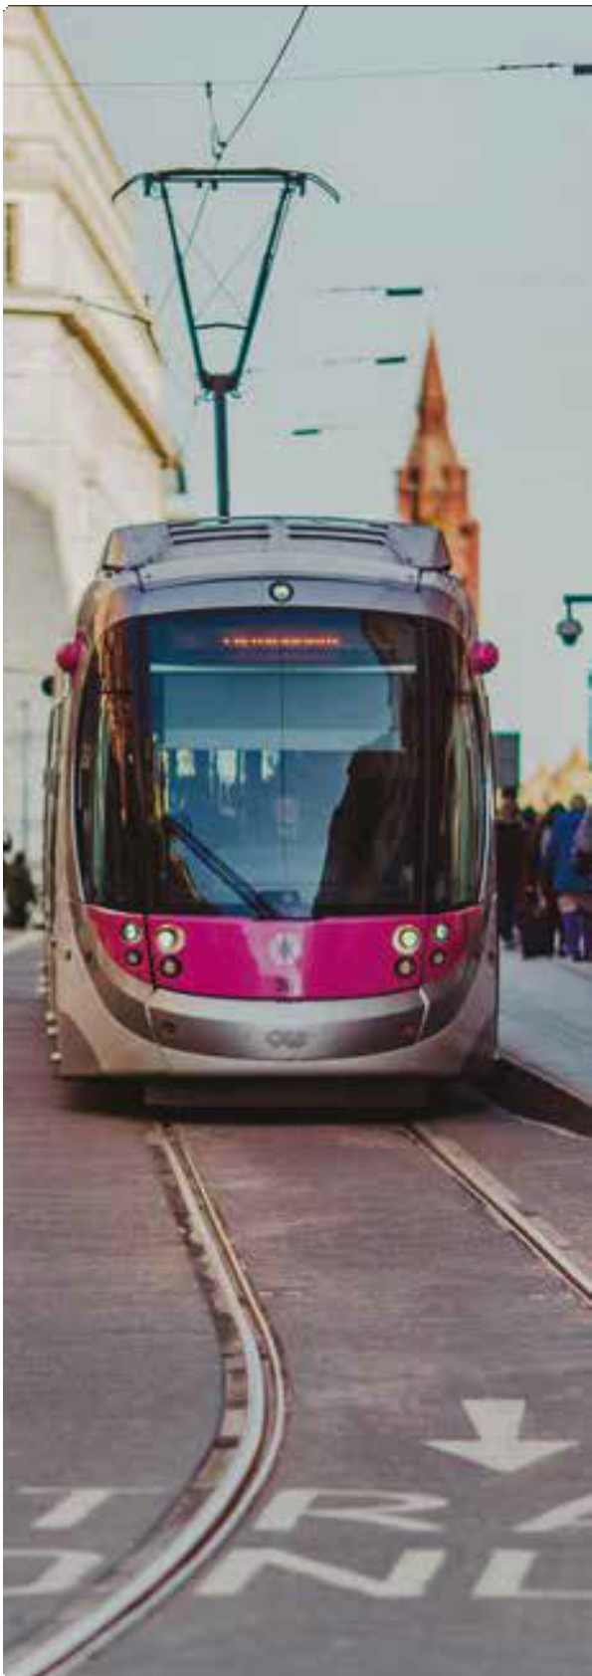
29

Clean air zone
Birmingham plans to introduce a Clean Air Zone (CAZ) covering all roads within the A4540 Middleway Ring Road during 2020.
The CAZ will start and terminate at the Middleway Ring Road and the University will be within the clean air zone, meaning the University is within its bounds and would benefit from the expected air quality improvements.
Within the CAZ, vehicles that do not meet emissions standards will be required to pay a fee.
It is expected that the implementation of the CAZ will improve the University environment, improving its attractiveness and liveability.

City centre public/mass transport transformation
As noted previously, significant investment is proposed for public transport improvements in Birmingham’s city centre. The draft Transport Plan described in previous paragraphs sets the stage for this through the proposals to restrict car access through the city centre and reallocate roadspace.
Sprint is proposed to stop on James Watt Queensway, with cross-town bus services stopping on Jennens Road. It is therefore important to ensure that pedestrian routes through the University provide direct access to these bus stops, with consideration also given to providing public space enhancements around them.

Wider city centre masterplanning - Snow Hill masterplan and Curzon Street masterplan
As both of these masterplans contain public realm connections linking to the University, a key consideration for the University masterplan is to ensure that public realm on campus connects to these wider city centre proposals so that walking between the urban core and the University is seamless and enjoyable.

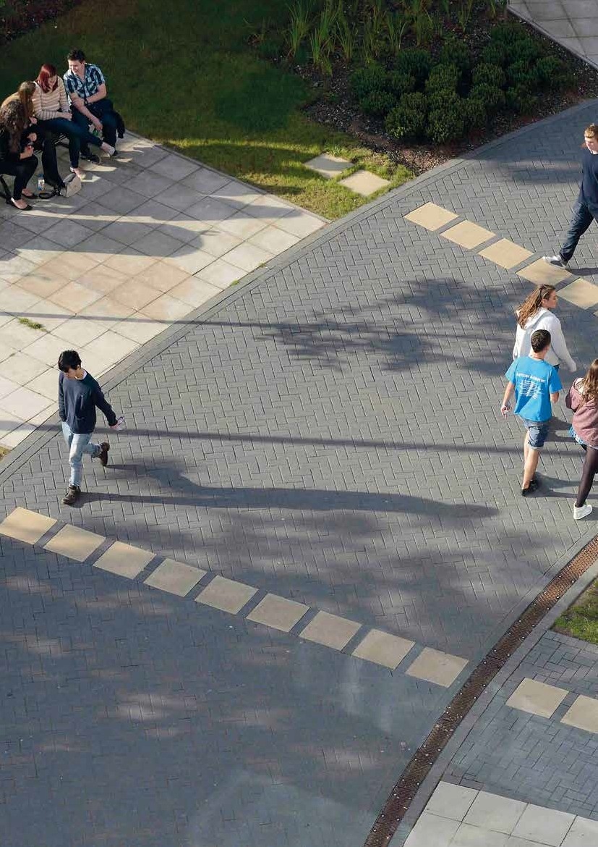TRANSPORT STRATEGY

30

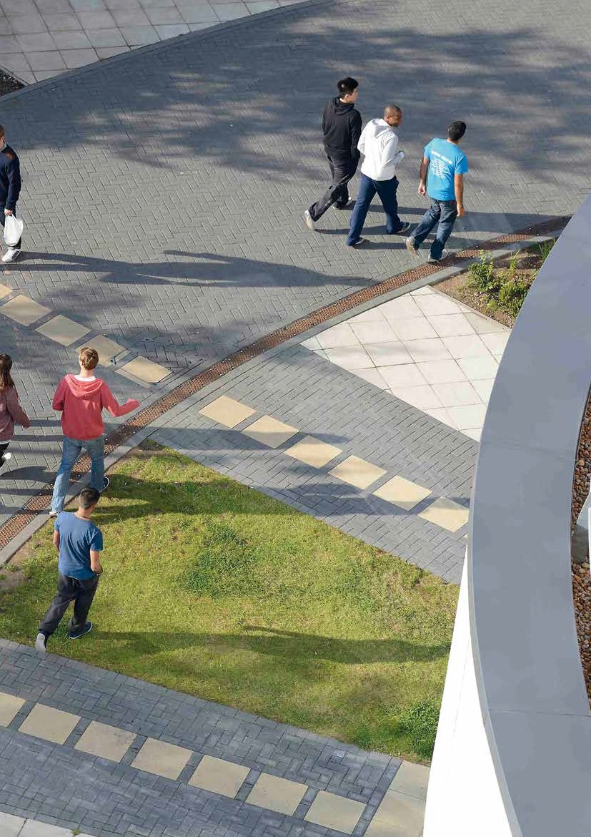

31

TRANSPORT STRATEGY

INTRODUCTION

As outlined in previous sections, Aston University’s Transport Strategy needs to respond to:
- A set of overarching drivers for change, including climate change.
- A set of policy and spatial changes and investments proposed in the city centre, including the implementation of the clean air zone.
- The specific requirements of the University, including addressing the future of the car parks.
The impacts of the drivers for policy and spatial change have been described in previous sections. In summary, it can be anticipated that:
- There will be increasing restrictions on access to the city centre by private car and a strong focus on mode shift towards using walking, cycling, and public transport to access the city centre.
- There is an increasing focus on transforming the city centre so that it is liveable and walkable.
- There will be significant investment in public transport, cycling and public realm within the city centre.
- Rail connections to other cities in the United Kingdom will be central.
The University also wishes to transform its campus and improve the connections between it and the wider city centre.
For the University and the wider city, it is important that this is done in a coordinated way with the emerging plans for public realm, cycling and public transport investments.
The strategy, therefore, addresses what the University can do and also what it needs others to do.
The four strands of the strategy are:

Making the shift
This recognises the need to ensure that most travel to and from the University is undertaken by active, sustainable, shared and efficient modes of transport. A key component of this will be the continuing development of ‘soft‘ measures to encourage the use of sustainable modes of transport, including developing an approach to the granting of parking permits that supports and is consistent with this.

Building it in
This strand is about ensuring that the campus layout, public realm and facilities encourage and prioritise the use of sustainable modes of transport, and that all new buildings contain the appropriate shower and locker facilities needed by users.
Ensuring that the approach to car parking provision for visitors, the public, staff and students is also part of this strand to support the shift towards active, sustainable, shared and efficient modes of transport.

Changing the context
There will also be a need to work with Birmingham City Council and Transport for West Midlands, in particular to ensure the University is better integrated for walking and cycling with the surrounding city, connections to the stations are direct and of high quality and the University is served by high frequency and high quality public transport.
This strand is therefore about partnership working and ensuring the University’s priorities are promoted.

Brave new world
There is significant discussion about the future of transport, and this strand is therefore about ensuring that of new transport technologies and information are captured and used for the benefit of the University, its students and its staff.
The following two pages contain firstly, a summary of the strands of the strategy and their respective
delivery actions and secondly, a plan which illustrates spatially how these actions fit together. Following these, summary pages provide more detail about the four strands of the strategy.

32

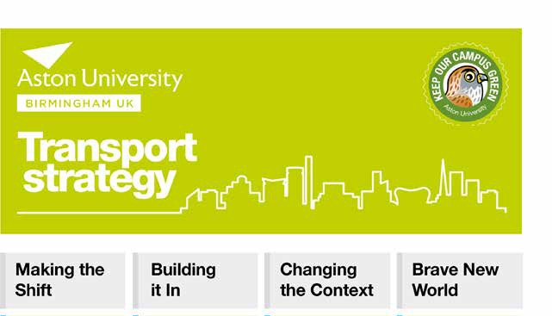TRANSPORT STRATEGY SUMMARY

- Develop a branded communication plan and marketing
campaign to promote the use of walking, cycling and public transport to access the University.
- Provide a programme of incentives to travel to the university on foot, by bike or public transport.
- Working with transport operators, authorities and suppliers to provide discounted public transport tickets and equipment for walking and cycling.
- Salary sacrifice scheme for staff to help pay for season tickets, travel cards, bicycles and other equipment/clothing for walking and cycling.
- The development of a parking permit policy to support the delivery of minimal car parking on campus.
- Establish staff and student sounding boards to support delivery of the transport strategy.
- The delivery of a high quality public realm ‘core’ through the campus that is beautiful, safe and accessible.
- The delivery of a high quality cycle network through the campus that is suitable for all ages and abilities.
- The delivery of a cycle ‘hub’ for cycle repair, cycle parking/storage, and in future hire.
- The increased provision of showers, changing facilities and lockers, including in all new/refurbished buildings.
- The increased provision of seating.
- The provision of improved wayfinding.
- The expansion of cycle parking and its provision at building entrances.
- Develop a high quality, safe, accessible city centre public realm between the university, the rail stations and other key destinations.
- Develop safe and accessible crossing facilities across the A38.
- Transform Jennens Road and James Watt Queensway into urban boulevards that are attractive for walking and cycling and easy to cross.
- Development of two transport interchange ‘hubs ‘adjacent to the University.
- Connect A38 and A34 ‘blue’ cycle routes past the University.
- Establish formal joint working arrangements with BCC, TFWM and transport operators.
- Develop the ‘Aston App’ to provide enhanced travel information and collect data about travel behaviour and issues.
- Provide relevant data that is collected about transport and
movement in an ‘open data’ format.
- Expand the availability of real time public transport information on campus.
- Explore opportunities for trialling innovations in mobility/transport developed by the University or others.
- Develop agile working facilities.
- Develop virtual learning environments.

33

TRANSPORT STRATEGY SUMMARY - SPATIAL PLAN
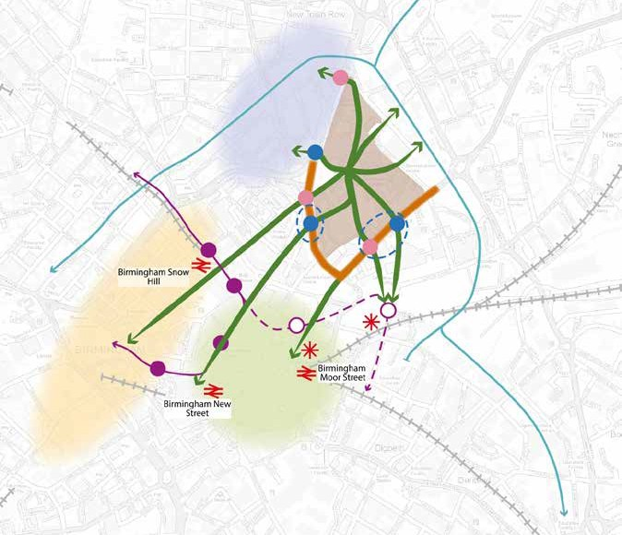

High quality public realm to provide connections and destinations within the university to the key assets within the rest of the city centre

Provide new high quality crossing facilities

Enhanced existing crossing facilities
Transform streets into urban boulevards that are attractive to walk and cycle along and are fronted by buildings

Public transport hub Proposed HS2 stations Current rail
Existing Metro Proposed Metro
Canal

Retail district Business district Student village Aston University

34

MAKING THE SHIFT
There is a need to continue to increase the number of people who travel to the University on foot, by bicycle and by public transport (active, shared, sustainable and efficient transport).
PROPOSED ACTIONS
Short Term
- Develop a branded communication plan and marketing campaign to promote the use of walking, cycling and public transport to access the University.
- Provide a programme of incentives to travel to the university on foot, by bike or public transport.
- Work with transport operators, authorities and suppliers to provide discounted public transport tickets and equipment for walking and cycling.
- Introduce a salary sacrifice scheme for staff to help pay for season tickets, travel cards, bicycles and other equipment/ clothing for walking and cycling.
- Begin the development of a parking permit policy to support the delivery of minimal car parking on campus.
- Establish staff and student sounding boards to support delivery of the Transport Strategy.
One of the key ways of doing this is by promoting and incentivising the use of these modes through ‘soft’ measures.
Aston University already have a successful travel plan, and this can continue to be developed and strengthened.
One of the key levers to encourage the use of sustainable modes of transport will be to limit on-site parking to those who have a personal or operational need to bring their car to work.
A set of actions are proposed to the right to deliver this element of the strategy.

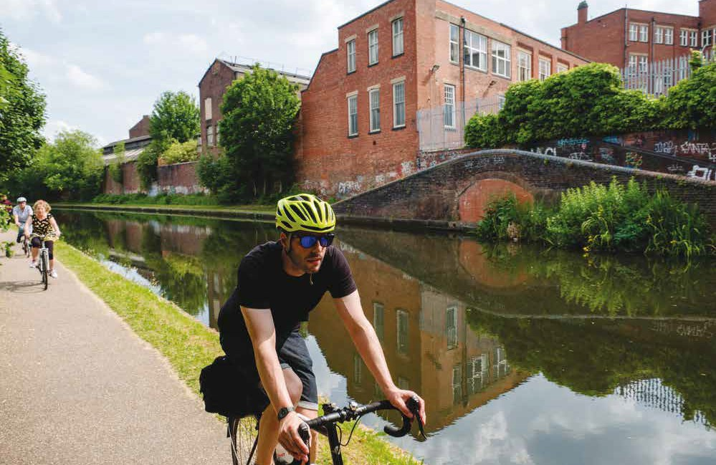

35

BUILDING IT IN
As well as promoting sustainable transport, it is important that the physical environment and
PROPOSED ACTIONS
Short Term
- Increase the provision of seating.
- Improve wayfinding on campus.
- Expand the amount of cycle parking, particularly at building entrances.
Medium Term
- Deliver a high quality public realm ‘core’ through the campus that is beautiful, safe and accessible.
- Deliver a high quality cycle network through the campus that is suitable for all ages and abilities.
- Deliver a cycle ‘hub’ for cycle repair, cycle parking/storage, and, in future, cycle hire.
- Increased the provision of showers, changing facilities and lockers, including in all new/refurbished buildings.
infrastructure within the University supports walking, cycling and access to the key public transport nodes.
The design and layout of the campus and the facilities provided within it are, therefore, critical. This includes the design of buildings and public realm and the relationship between them. It also includes the facilities provided within the University.
The approach to the provision of car parking both for students, staff and visitors is also important and needs to align with a new policy for the granting of parking permits.
This strand of the strategy relates to land and investment decisions over which the University has control, with proposed actions are listed to the right.

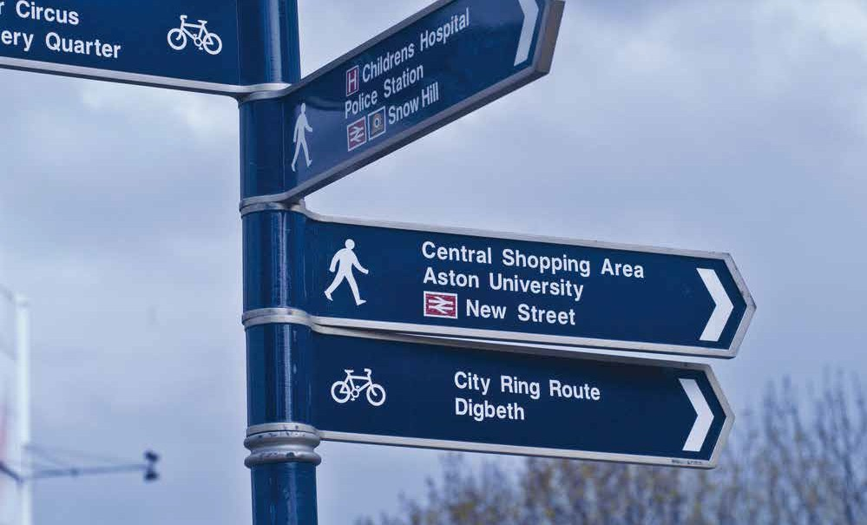

36

CHANGING THE CONTEXT

As noted earlier in this document, the University has a number of objectives in relation to transport that need to be delivered by others to ensure that:
- The University is better integrated for walking and cycling with the surrounding city.
- Connections to the stations are direct and are of high quality.
- The University is served by high frequency and high quality public transport.
- Phasing of investment on and off the University campus is aligned as far as possible.
- The design of new infrastructure adjacent or close to campus matches the aspirations of the University administration.
- Access to the stations and city centre is improved for disabled users.
These objectives are not just about transport investments, as ensuring that walking connections are overlooked is a key consideration that is ultimately related to masterplanning and the design of new buildings.
Aston University will, therefore, need to work closely with Birmingham City Council and TfWM to deliver the University’s aspirations. A set of proposed actions to do this are listed below.

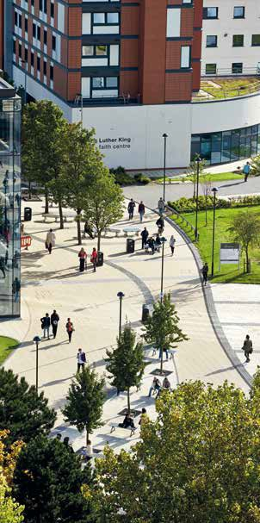
PROPOSED ACTIONS
Short Term
- Establish formal joint working arrangements with BCC, TfWM and Transport Operators.
Medium Term
- Transform Jennens Road and James Watt Queensway into urban boulevards that are attractive for walking and cycling and easy to cross.
- Development of two transport interchange ‘hubs’ adjacent to the University.
- Connect A38 and A34 ‘blue’ cycle routes past the University.
Long Term
- Develop a high quality, safe, accessible city centre public realm between the University, the rail stations and other key destinations.
- Develop safe and accessible crossing facilities across the A38.

37

BRAVE NEW WORLD
This strand is about ensuring, as far as possible, that the benefits of new transport related technologies and information are captured and used for the benefit of the University, its students and its staff.
POTENTIAL ACTIONS
Short Term
- Develop agile working facilities.
- Develop virtual learning environments.
Medium Term
- Develop the ‘Aston App’ to provide enhanced travel information and collect data about travel behaviour and issues.
- Expand the availability of real time public transport information on campus.
- Explore opportunities for trialling innovations in mobility/transport developed by the University or others.
It is also about ensuring that emerging technologies and their implications or opportunities are noted by the University. Potential actions are suggested to the right.

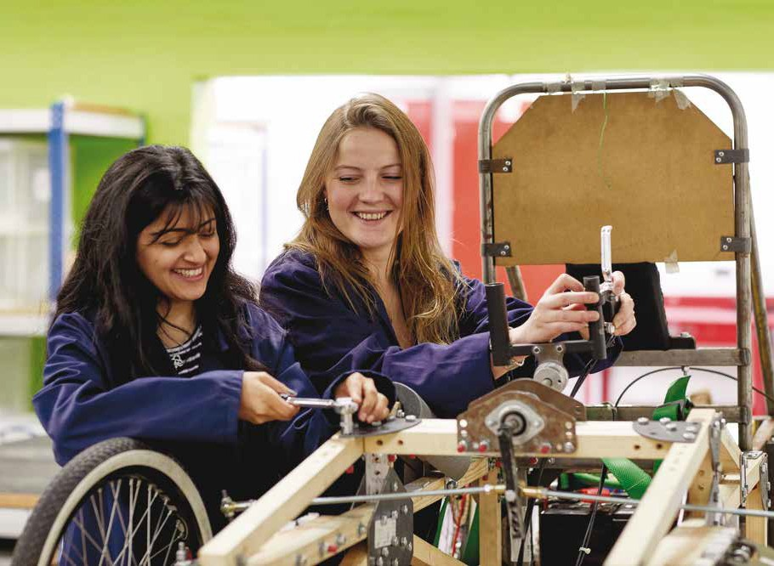

38

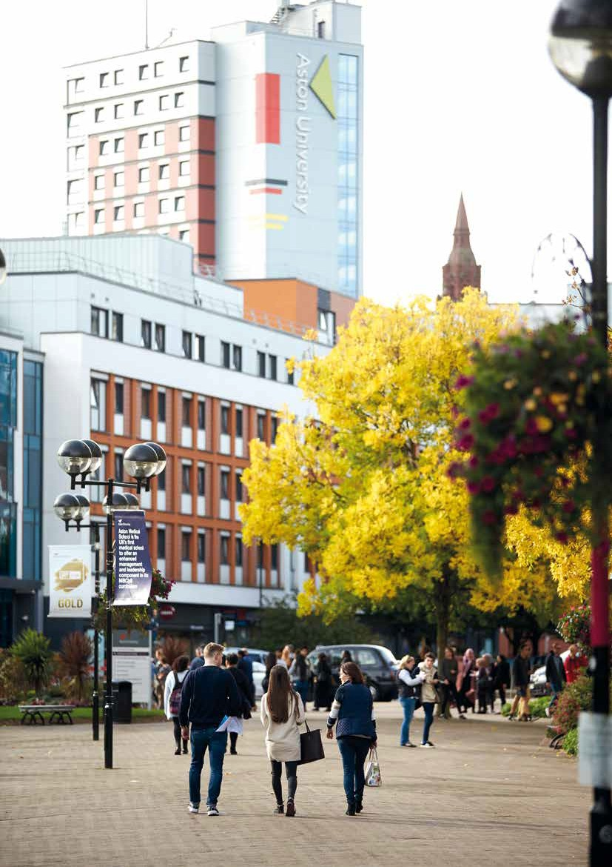

39

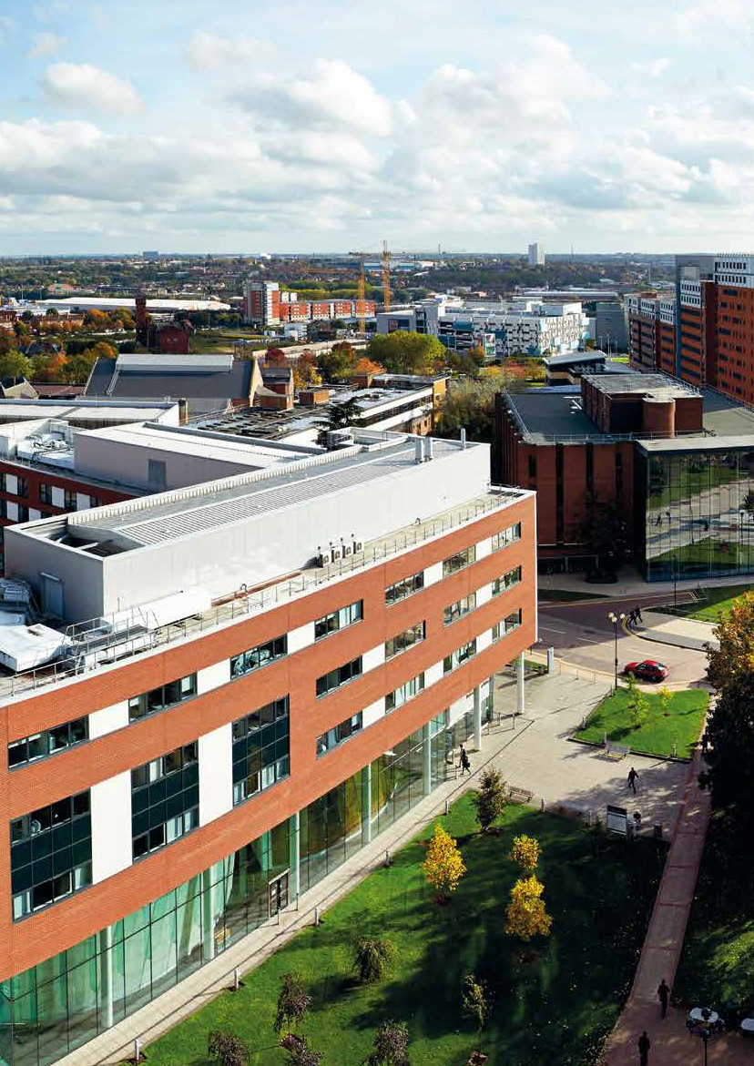

www.aston.ac.uk

