

Guidance for new build and refurbishment projects

June 2020

**Sustainable Construction Specification**

Version Control

|  |  |
| --- | --- |
| **Date of change** | **Details of change** |
| January 2020 | Inclusion of refurbishment project spec. |
| June 2020 | Addition of 3.3 Building physics design approach |
|  |  |
|  |  |
|  |  |
|  |  |
|  |  |

# Executive Summary

The University is aware of the impact that construction has on the environment, whether it is a new build or refurbishment works. Between 2010 and 2015 the University assessed all its new building projects using the BREEAM standard, with all projects gaining a BREEAM Excellent accreditation.

However, this mechanism for increasing the sustainability of a new construction project is not considered by some as the best way to drive sustainability into buildings, plus is deemed a costly exercise (typically adding 3-5% of the capital cost onto a budget). Furthermore, high BREEAM rated buildings can still perform poorly on their energy ratings.

The University’s existing specifications and procedures for building construction projects were compared to that of BREEAM (see Appendix 1). It was felt that the University’s own requirements easily met those of BREEAM Very Good. Furthermore, the University adopted the SKA HE scheme in 2016 for all refurbishment projects over £1 million and to embed the SKA methodology into projects of lesser value through informal assessment.

Integrating our internal specifications with a number of Good Practice measures described in BREEAM and SKA will help to embed sustainability into capital development projects, have lower emissions than a standard build, reduce maintenance and running costs as well as have a building fit for purpose that staff and students enjoy using.

Contents

Executive Summary 3

**New Building Guidelines** 6

Introduction 6

1. Management 8

1.1 Project brief 8

1.2 Construction and handover 8

1.3 Soft landings 9

1.4 Registration with the Considerate Construction Scheme 10

1.5 Sub Metering 10

1.6 Construction phase CO2 emissions 11

1.7 Sustainable Timber procurement 11

1.8 Embedded Environmental Management System 11

1.9 Building Design Fit for purpose 12

1.10 Building User Guide 12

1.11 Climate Change Adaptation 13

1.12 Sustainability Assessment 13

2. Wellbeing 14

2.1 Lighting (Wellbeing) 14

2.2 Ventilation Rates 15

2.3 Low VOC and VOC monitoring 15

2.4 Thermal comfort assessment 16

2.5 Water quality 17

2.6 Acoustic survey 17

2.7 Safety and security 17

3. Energy 18

3.1 Energy performance and modelling 18

3.2 Energy efficient lighting (including external lighting) 18

3.3 Building physics design approach 19

3.4 Energy efficient equipment 19

3.5 Energy efficient specialist ventilation 20

3.6 Energy efficient lifts 20

3.7 Energy efficient hand-dryers 20

3.8 Automatic metering 20

3.9 Low and zero carbon technologies 21

4. Water 22

4.1 Leakage detection devices 22

4.2 Low flow WCs 22

4.3 Sanitary supply shut-off 22

4.4 Efficient taps 22

5. Travel and Transport 23

5.1 Travel plan 23

5.2 Cycle parking 23

6. Materials 24

6.1 Hard landscaping 24

6.2 Responsible Sourcing 24

6.3 Insulation 25

6.4 Robustness 26

7. Waste 27

7.1 Resource Management Plan (RMP) 27

7.2 Recyclable waste storage space 28

8. Ecology 29

8.1 Biodiversity Guidelines 29

9. Pollution 31

9.1 Low impact refrigerants 31

9.2 Refrigerant leak prevention 31

9.3 Flood risk assessment 31

9.4 Night time light pollution 32

9.5 Noise attenuation 32

**Refurbishment Project Guidelines** 33

Introduction to SKA HE 34

Large Projects (over £1 million) 34

Small Projects (under £1 million) 35

Appendix 1: Table comparing current University specification with BREEAM ratings. 38

# Introduction

# **New Building Guidelines**

Instead of committing to the BREEAM system or another catch-all scheme based on credits, sustainability needs to be appropriate to the project in question.

It is vital that all aspects of a project relating to sustainability are:

* Based on site specific information
* Consulted with all parties
* Owned by the Design Team and end user

In this way, a more tailored approach to sustainability needs to be incorporated into every project, whereby genuine carbon savings can be made at lower costs.

Sustainable Considerations

Architect, Mechanical and Electrical Designers and all other contractors will be asked to consider the following within all new build and refurbishment:

* Construction site impacts
* Source of materials used, material re-use, embodied life cycle impact and robustness
* The use low and zero carbon technologies and reduced emissions by building users;
* The waste that is produced and disposed of on site and its logistics;
* Potential pollution through watercourse, air emissions, external light and noise;
* The health and wellbeing of building users, in particular the use of natural daylight; occupant thermal control and indoor air and water quality;
* The mitigation/ enhancement of ecological value;
* Pedestrian and cyclist facilities;
* Using the building process as an educational tool for local schools
* Look at how to increase the use of local companies; and
* Access to amenities and public transport network connectivity.

A majority of all aspects in this document can be found in more detail within our other Estates guidelines, which can be found on the Estates website [www.aston.ac.uk/about/estates/](http://www.aston.ac.uk/about/estates/)

# 1. Management

## Project brief

For all projects a project brief is written with the client, building occupier and design team involved, contributing to the decision-making process for the project. As a minimum this includes meeting to identify and define their roles, responsibilities and contributions during the following phases:

1. Design
2. Construction
3. Commissioning and handover
4. Occupation

The roles and responsibilities outlined above include consideration of:

1. End user requirements
2. Aims of the design and design strategy
3. Particular installation and construction requirements
4. Occupiers budget and technical expertise in maintaining any proposed systems
5. Usability and manageability of any proposals
6. Production of documentation
7. Commissioning, training and aftercare support

The design intent needs to be clearly communicated to the contractor and that the equipment being purchased aligns with the design intent. The Project Manager should ensure the contractor understands their role in the soft landings process and the outcomes that are to be achieved. The following should be clearly detailed to the contractor:

1. The role of the contractor in the soft landings process
2. The performance targets that have been set
3. The rationale for the selection of energy using equipment
4. The reasons for the controls that have been selected
5. The importance of the proposed sub-metering and BMS/AMT strategy

There is a schedule of training identified for relevant building occupiers/premises managers (based appropriately around handover and proposed occupation plans) which includes the following as a minimum:

1. Contents of the Building User Guide(s) (see 1.10 Building User Guides)
2. Design strategy
3. Installed systems and key features (maintenance, operation, replacement, repair)
4. Documentation to be provided (e.g. user guide, log book etc.)
5. Training responsibilities

## Construction and handover

The principal contractor accounts for a thermographic survey within the project budget and program of works. Once construction is complete a thermographic survey of the building fabric is undertaken. Any defects identified via the post construction inspections are rectified.

The survey confirms:

1. Continuity of insulation in accordance with the construction drawings
2. Avoidance of excessive thermal bridging
3. Avoidance of air leakage paths through the fabric (except through intentional openings)

An appropriate project team member is appointed to monitor and program pre-commissioning, commissioning and, where necessary, re-commissioning on behalf of the client. All building services are included in the commissioning schedule and commissioning is to be carried out in line with current Building Regulations. The principal contractor accounts for the commissioning program, responsibilities and criteria within the main program of works.

## Soft landings

More detail can be found within the Estates Soft Landing Guidelines.

All the following are required

**At design stage:**

* Ensure a contract/appointment is in place to guarantee the designer and contractor returns to fine-tune systems throughout the first year of occupation.
* The contract/appointment should set a point of contact from the project team once the project is complete. This person is to liaise with the building operators and occupants to ease the handover process and to allow building users and building maintenance staff to ask questions about user controls, etc.

**At handover stage:**

* The point of contact should carry out ‘walkabouts’ and stay on site, at least one day a week, for the initial 8 weeks of occupation. For projects valued under £2m to visit site at least one day every two weeks.
* Ensure that the contractor is appointed to validate the operational performance of the building against the design parameters and soft landing performance targets. This should include validating sub-meter readings.

**At occupancy stage:**

Carry out fine tuning and review of systems.

* Undertake seasonal/annual commissioning for complex systems (complex systems are defined in D70 Soft landings: commissioning, handover and training).
* The soft landings point of contact should record lessons learnt from the design, construction, operation and handover on behalf of the client to feedback into new projects.
* Carry out a Post Occupancy Evaluation (POE) 12 months after total completion and full occupation. The POE should provide a review of the performance of the building against the soft landings performance targets set at the start of the project. The POE should include:
  + a review of energy use against design benchmarks;
  + an occupant satisfaction survey that covers the building users views of their working environment; and
  + an audit of the building’s engineering and architectural systems.

## Registration with the Considerate Construction Scheme

Aston University is a Client Partner of the Considerate Constructors Scheme (CCS).

Where possible the Contractor should look to exceed the requirements of the scheme gaining a CCS score of 35 or more. Benefits include a safety construction site, improved appearance, enhanced respect for the community, and highlights the high value of the workforce.

## Sub Metering

**Construction phase**

The University is able to remove all construction projects from its annual emission reporting for Scope 1 and 2 (direct) emissions. Therefore, the electricity and (if used) gas/ heat and water needs to be sub metered at the start of the construction phase with start/end readings sent to the project manager at the end of the project.

**End-use sub metering**

Further details of meter requirements are described in the Estates Electrical Guidelines.

Separate meters are required for:

* lighting – a minimum of one sub-meter per floor and per tenancy area within a floor;
* small power – a minimum of one sub-meter per floor and per tenancy area within a floor;
* renewables – PV units and other renewable energy sources to monitor performance;
* humidification;
* major fans with air handling units with greater than 10kW input power;
* lifts;
* cooling systems with greater than 20kW input power;
* data centres;
* space heating (including combined heating and cooling systems such as variable refrigerant flow (VRF) systems with greater than 50kW input power);
* domestic hot water (if they are powered by electricity) – a minimum of one sub-meter per floor and per tenancy area within a floor (excluding tea points); and
* any other major energy consuming items that is considered a specialist area

All sub meters should be specified as ultra-sonic meters that have a MOD-BUS card connected so that actual readings can be send to the University’s AMR system.

## Construction phase CO2 emissions

A site-specific construction travel plan needs to be produced that identifies ways to reduce vehicle movements and must consider the criteria suggested below:

* Design of appropriate service facilities and off-street loading where practical.
* Procurement of goods and services including feasibility of sourcing items locally or from the same supplier and procuring off-site manufactured items for larger components.
* Commitment by operators to follow best practice measures e.g. signed up to the FORS scheme, use fuel efficient vehicles, or low carbon modes of delivery (e.g. rail and train).
* Operational efficiency demonstrating pro-active management of deliveries to reduce the number of vehicle deliveries.
* Waste management options for segregating, storing and removing waste including feasibility of using a Construction Consolidation Centre.
* Targets and monitoring are determined at the start of the project and reviewed throughout construction.

The principal contractor must also monitor site transport, including deliveries of materials and plant to site, and movement of waste from site. The following should be recorded and displayed on site:

* vehicle distance to and from site;
* types of vehicle used; and
* the calculated CO2 emissions

## Sustainable Timber procurement

Confirmation that all site timber used on the project is sourced in accordance with the UK Government’s Timber Procurement Policy needs to be shown.

## Embedded Environmental Management System

The University is accredited to the environmental management system (EMS) of ISO 14001, ISO 50001 (Energy Management System) and Eco Campus Platinum. The principal contractor for the project should support the University commitment to the environment and either operate their own Environmental Management System covering their main operations or they must be aware of their most significant environmental impacts and are trying to reduce these. The EMS must be either certified by a third party (e.g. ISO 14001, EMAS, Green Dragon or iiE).

## Building Design Fit for purpose

A life cycle analysis needs to be carried out based on the concept design/design development proposals. It needs to be completed for the following stages and uses a study period of 25 years, shown in real and discounted cash flow terms:

* Construction;
* Operation - includes as a minimum, utilities, cleaning, management costs; and
* Maintenance - includes as a minimum, planned maintenance, replacements and repairs costs.

As part of this analysis, a maintenance strategy needs to be developed based on the above analysis and includes:

1. The extent to which maintenance has been designed out and how support and/or access systems have been included in the specification to facilitate safe, efficient and cost-effective operation and maintenance.
2. How the removal and replacement of major plant and equipment, within the design life of the building, has been facilitated by the building design and specification (layout/access etc.).
3. A management plan for the landscaping if appropriate.

A number of these aspects are stipulated in the Construction and Management Regulations (CDM), however the above brings such requirements up to a level of Good Practice.

## Building User Guide

A building user guide (BUG) for non-technical staff is produced that avoids using technical jargon and includes clear illustrations (diagrams/photographs) to assist comprehension, complementing the required O&M manuals. The guide should include:

* a brief explanation of BUG purpose;
* an explanation of the design intent and the heating/cooling strategies;
* an overview of the controls/BMS;
* building energy performance records;
* energy/water metering, monitoring and targeting strategy;
* summary of areas, occupancy, WC provisions and fire strategy;
* building waste, recycling and reuse strategy;
* item-specific user operational guidance such as cleaning of specific materials; and
* reference page to other relevant documents.

A BUG for tenants/occupants needs to be produced that is 1-2 pages, avoids technical jargon and includes clear illustration to assist comprehension. It should include:

* clear information on all controls relevant to the tenants/occupants (blinds/local heating/lights/etc.);
* buildings waste and recycling strategy; and
* energy/water metering, monitoring and targeted strategy.

A template for both these documents are provided by the ECD team to go with this document.

## Climate Change Adaptation

An appraisal of the degree to which new buildings and large refurbishment projects are informed by potential future flooding and overheating issues must be made.

## 1.12 Sustainability Assessment

As part of Birmingham City Councils Planning requirements, all new buildings need to do a Sustainability Assessment. This includes having a pre-construction BREEAM report to indicate what rating the new building could achieve from its designs, if it were to rated.

Please see Birmingham City Council’s Planning Requirements.

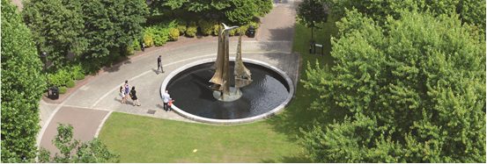

# 2. Wellbeing

## 2.1 Lighting (Wellbeing)

**Daylight**

Effective use of available daylight reduces the need for artificial lighting and provides a more natural environment for building occupants. An average daylight factor of 2% or greater; or the Average Daylight Illuminance (ADI) values of 300 lux for 2,000 hours need to be met. The criteria applies only to occupied floor spaces such as office/workshop/teaching spaces. The criteria does not apply to circulation spaces or non-occupied spaces such as toilets and store rooms.

**Lighting Design**

The lighting levels should be in accordance with BS EN 12464-1: 2012, the SLL Code for Lighting and CIBSE Lighting Guides for the specific area. These can also be found in the University’s Electrical Specification document found on the ECD web pages.

Additionally, the following shall be evidenced as being considered in the lighting design:

* Surface reflectance as per SLL Code for Lighting Parameters (2012) for ceilings, walls and floor respectively as a minimum.
* Uniformity
* Colour temperature
* Colour rendering
* Vertical illuminance of teaching spaces
* Highlight aspects of the lighting design that specifically focused on wellbeing of occupants such as local controllability; architectural fittings; and mood lighting.

**Daylight Glare Control**

For office, meeting and all general teaching spaces all of the following criteria must be met:

* occupant-controlled window coverings (typically blinds or screens) are fitted to the external windows and atria that receive sunlight directly or indirectly;
* coverings are designed to provide optimum glare control and allow the best possible retention of views with the coverings drawn closed;
* fabric screens, where specified, have a visual light transmittance (VLT) of less than 10% (excluding occasions that require blackout blinds); and
* have solar protective coating (SPC) or Energy Solar Protective Coating (ESP).

For spaces where visual display units (VDU) e.g. PC suites, library PCs, retail tills, ATMS, TV screens in lecture theatres are used one of the following criteria must be met:

* the VDU must be positioned so that light from the window does not fall on it or cause reflections;
* the VDU must be fitted with an anti-glare screen; or
* the workspace must be provided with a screen that the staff can position to shield the VDU from the source of glare.

**Outside views**

The aim of having outside views is to ensure high quality workspaces and wellbeing for occupants. Key to this are two factors: reduction of eye strain by ensuring access to long distance views, and the psychological benefit experienced from views to naturally lit spaces.

All workstations intended for non-transient workers are within seven meters of external windows or benefit from an outside view; the view must be visible within 65 degrees rotation from the normal working position at those workstations.

For the purpose of these criteria:

* transient workers include visitors and those using touchdown workstations;
* ‘hot-desking’ or shared desks are considered to be part of the non-transient workstation provision; and
* outside views are views to external and atrium spaces that benefit from full daylight.

## 2.2 Ventilation Rates

Ventilation rate is at least as good as the rates shown below for each of the spaces:

|  |  |
| --- | --- |
| **Building/room type** | **Suggested air supply rate** |
| Office space | 12 litres per person per second |
| Retail space | 5 litres per person per second |
| Toilets | 5 air changes per hour |
| Corridor | 10 litres per person per second |
| Lecture halls | 10 litres per person per second |
| Seminar rooms | 10 litres per person per second |
| Teaching spaces | 10 litres per person per second |

## 2.3 Low VOC and VOC monitoring

The following products must have low or zero VOC emissions: varnishes;

* wood panels, timber structures, wood flooring;
* resilient, textile and laminated floor coverings;
* flooring and wall adhesives;
* wall coverings;
* suspended ceiling tiles;
* joinery; or
* furniture

The definition of ‘low’ VOC emissions is product dependent and is based on compliance with one of the standards below.

The product has been awarded one of the following labels:

* EMICODE – Levels 1 or 2;
* Blue Angel;
* M1;
* Eurofins Indoor Air comfort GOLD standard;
* Green Label Plus Classification; or
* Natureplus.

Or

The product has been tested to the following British Standards, and has passed:

* Varnishes: BS EN 13300:2001;
* Wood panels: EN 13986:2004;
* Timber structures: EN 14080:2005;
* Wood flooring: EN 14342:2005;
* Floor coverings: EN 14041:2004;
* Suspended ceiling tiles: EN 13964:2004;
* Flooring adhesives: EN 13999-1:2007;
* Adhesives for hanging flexible wall coverings: BS 3046:1981;
* Wall-coverings: EN 233:1999, EN 234:1997, EN 259:2001, EN 266:1992.

These products should all meet the requirement for formaldehyde E1 as tested to standard BS EN 717-1:2004

## 2.4 Thermal comfort assessment

Thermal comfort is an important criterion for occupant wellbeing and is typically the issue that produces greatest occupant dissatisfaction. Where occupants can control indoor air temperature and there is dissatisfaction, energy efficiency targets are missed due to strategies being overridden.

The use of thermal modelling at the design stage should aim to select the HVAC strategies that provide optimal comfort and minimise overheating risks.

Thermal comfort modelling to CIBSE AM11 standard has been carried out at the design stage; the results of this modelling are used to select a service strategy that aligns with the following guidance:

* AM11 Building Performance Modelling 2015, CIBSE Applications Manual A M11, CIBSE, 2015.
* Environmental design (8th edition), Guide A, CIBSE, 2015

The strategy for proposed heating / cooling system(s) demonstrates that it has addressed the following:

1. Zones within the building and how the building services could efficiently and appropriately heat or cool these areas e.g. consider the different requirements for the central core of a building compared with the external perimeter adjacent to the windows.
2. The amount of occupant control required for these zones, based on discussions with the end user (or alternatively building type/use specific design guidance, case studies, feedback).

## 2.5 Water quality

Building services water systems: minimising risk of contamination

1. All water systems in the building are designed in compliance with the measures outlined in the Health and Safety Executive’s “Legionnaires' disease - The control of legionella bacteria in water systems”. Approved Code of Practice and Guidance, 20001 and, where relevant, other industry/sector best practice guidance (see Compliance notes).
2. Where humidification is required, a failsafe humidification system is provided.

Building occupants: Provision of fresh drinking water

A wholesome supply of accessible, clean and fresh drinking water is supplied, as follows:

1. Chilled, mains-fed point-of-use water coolers accessible to pupils/students/users/staff (as applicable) throughout the day.
2. Provision in safe and convenient locations e.g. dining/assembly halls, class-rooms/common rooms, wide corridors, indoor social areas, changing rooms/gymnasia, concourse.
3. One compliant point-of-use water cooler is provided for every 200 building users, subject to a minimum of one water cooler being provided for any building with less than 200 building users.
4. All coolers must be attached to both the wall and the floor to prevent vandalism, and contain security covers to protect all water and electrical connections.

## 2.6 Acoustic survey

A suitably qualified acoustician is appointed (see definition below) by the client at the appropriate stage of the project to provide early advice on influencing outline design solutions to:

* External sources of noise impacting the chosen site
* Site layout and zoning of the building for good acoustics
* Acoustic requirements for users with special hearing and communication needs,
* Acoustic treatment of different zones and facades.

An acoustician who is a corporate member (or higher) of the Institute of Acoustics or whose company holds membership of the Association of Noise Consultants is part of the design team and the criteria from the current BB93, or FIS Guide to Office Acoustics 2015, are used as design targets.

## 2.7 Safety and security

The project team have accounted for security considerations in the new building design and site layout through consultation with Aston University’s internal Security and Health and Safety Unit. The final design embodies the recommendations/solutions of the two departments.

# 3. Energy

With energy costs inevitably increasing over time and with the growth of our campus and student numbers it’s critical that any new building is as energy efficient as possible. Furthermore, new buildings typically have more energy intensive mechanical plant and larger lighting requirements then older buildings.

## 3.1 Energy performance and modelling

All new buildings should be designed to achieve an A rating on an Energy Performance Certificate and aim to obtain a first-year B rated Display Energy Certificate (dependent on user’s potential over consuming energy behaviour).

How this is implemented into the design of the building is down to a number of initiatives that can be achieved. The further requirements stated below will help to meet this.

**Energy modelling is undertaken in accordance with CIBSE TM54: Evaluating Operational Energy Performance of Buildings at Design Stage.**

A full dynamic thermal analysis must be undertaken at the detailed design stage. The model should include the energy use and heat gains associated with the equipment and the people that are likely to be in the space. A report must be produced, based on the findings of the modelling exercise that highlights the most appropriate passive design measure for the building and this report must show that the proposed measures save energy and meet thermal comfort requirements. At least one of the recommended measures must be implemented.

The energy model should be done at design and handover stage with the two stages compared to highlight if the building has achieved what it was designed to do.

## 3.2 Energy efficient lighting (including external lighting)

Constantly occupied areas, such as lecturer theatres, classrooms and/or open plan office spaces with a general illuminance of 300 to 500 lux, shall achieve a general lighting load of less than 7 W/m2. Front and back-of-house circulation areas with a general illuminance of 100 lux shall achieve a general lighting load of less than 4 W/m2.

Individual cellular offices should be a minimum of 8m2, so the above should not be an issue to meet. However, there may be rare exceptions were an office is less than 7m2 where this may cause an issue.

Space requirements are detailed in the University’s Space Policy Guidelines.

Light fittings and their controls must meet those that are in the Estates and Capital Development Electrical Specification document.

## 3.3 Building physics design approach

The heating, cooling, lighting, auxiliary power and energy production must be taken into account during the design phase along with the new building ‘skin’ to ensure a truly energy efficient and comfortable building. The traditional building envelope must switch from the concept of a static, single function building weather shield component to a dynamic, adaptive, and multifunctional façade.

In order to maximize energy efficiency of a building and provide building user comfort, the design needs to take into consider a number of aspects, including:

* The façades must be “in tune” with the local climate conditions and must efficiently exploit the natural resources (sun, wind, and climate), instead of working against them.
* The optimal façade is one that allows to properly adjust the transmitted heat flux, to store/release the energy, to tune the ventilation airflow rate, and finally, to adjust its transparency, as a function of the season, working conditions, and user preferences.
* Significant improvement in the energy efficiency can only be achieved by conceiving “active” and multifunctional components. Adaptive façade modules typically include energy generation/conversion systems, play a role in the ventilation (being used as air heat exchangers, air preheaters, ventilation outlets/inlets, ducts, etc.) and are combined with the heating/cooling/lighting installations.

The inclusion of low carbon, renewable technologies should not be included simply as a ‘bolt on’ to the design, but used as a synergic integration within the function of the building.

The University’s Space Heating and Ventilation Code of Practice benchmarks the benefits of different mechanical ventilation methods.

The University has a mechanical specification that should be used in designing mechanical systems.

## 3.4 Energy efficient equipment

The following equipment, if in scope, must be on the Energy Technology List (ETL), or meet the ETL criteria stipulated for the relevant equipment:

1. heat pumps
2. HVAC zone controls
3. boiler equipment;
4. motors and drives;
5. refrigeration equipment;
6. air-to-air heat exchangers;
7. localised rapid steam generators;
8. compressed air equipment;
9. warm air and radiant heaters;
10. food storage and display cabinets; and
11. bar cellar cooling equipment.

## 3.5 Energy efficient specialist ventilation

The following criteria are met where the spaces listed are within scope:

Catering kitchens

1. Design and refurbish kitchen ventilation and extraction systems in accordance with the guidance set out in CIBSE TM50, Energy efficiency in commercial kitchens.

Auditoria and event space

1. Heat recovery and/or air recirculation on main supply and extract air is provided.
2. Ventilation plant to areas is provided with variable speed drives and demand response with CO2 sensing.

Building entrances, including DDA pass doors, should meet one of the following criteria:

* no over door heaters/air curtains and implement a closed-door policy;
* use over door heaters/air curtains that only use heat from a VRF system or rejected heat (from cash machines if present, etc.) and automatically controlled to switch off out-of-hours and to moderate temperature;
* an entrance lobby and/or a revolving door with no over door heaters/air curtains; or
* sensor-controlled automatic rapid-opening/closing doors.

## 3.6 Energy efficient lifts

An analysis is undertaken of the energy usage of at least 2 lifts options using

ISO 25745-2:2015 Energy performance of lifts, escalators and moving walks -- Part 2: Energy calculation and classification for lifts.

The installed lift must as a minimum include:

* controls that allow for both standby and idle modes;
* LED only lighting; and
* a drive controller capable of variable-speed, variable-voltage, variable-frequency.

Further details on lifts can be found in the University’s Electrical Specification.

## 3.7 Energy efficient hand-dryers

The University has a standard specification of hand dryers that need to be installed called the [XLERATOR eco](http://www.exceldryer.com/products_xlerator_eco.php).

## 3.8 Automatic metering

Metering should be at a zone level that provides adequate information of how the building is used specifically and not just lighting and power. Rooms and any energy intensive equipment should be metered separately.

Metering and Automatic Metering requirements must meet those that are in the Estates and Capital Development Electrical Specification and Building Refurbishment document.

## 3.9 Low and zero carbon technologies

A feasibility study should be carried out by an energy specialist to establish the most appropriate local (on-site or near-site) low or zero carbon (LZC) energy source for the building/development.

Under the University’s obligations with the BDEC district heating scheme, Engie must have the opportunity to do a feasibility study on connecting any new buildings to the University’s scheme to provide low carbon heat to the building. This must be in line with the financial model that is outlined in the BDEC contract with the University.

**Guidance**

[Energy Technology List](https://etl.beis.gov.uk/engetl/fox/live/ETL_PUBLIC_PRODUCT_SEARCH)

[Space Policy Guidelines](http://www.aston.ac.uk/about/estates/the-teams/space-management/)

[Estates Electrical and Mechanical Specifications](http://www.aston.ac.uk/about/estates/policies/)

# 4. Water

## 4.1 Leakage detection devices

A system that can warn of water leaks is installed in all plant rooms where water feeds are situated (including incoming supply and tanks) and is on the Water Technology List (WTL). Alternatively, the Building Management System (BMS) can be programmed to monitor water consumption and report consumption outside of appropriate limits and raise an alarm. The alarm threshold should be adjustable based on actual consumption monitoring.

## 4.2 Low flow WCs

WCs have an effective flush volume of 4.5 litres or less and are on the Water

Technology List (WTL) or have an EU Water Efficiency Label.

## 4.3 Sanitary supply shut-off

A control system to isolate the water supply when the washrooms are unoccupied is specified and installed. This usually comprises a solenoid valve and occupancy sensor. The device must be on the Water Technology List (WTL) or comply with the WTL criteria. The shut-off system only needs to be applied to the cold-water supply to taps, WCs and urinals.

## 4.4 Efficient taps

Flow rate on taps used for hand wash basins is limited to 4 litres/minute up to a pressure of 5 bar +/– 0.2 bar and the tap fitting or flow controller is on the Water Technology List (WTL) or has an EU Water Efficiency Label.

The tap should be one of the following:

* automatic shut-off taps;
* electronic taps;
* low flow screw-down/lever taps; or
* spray taps

Where auto-shut off or electronic taps are specified these should be restricted to no more than 20 seconds’ flow in line with, and be on, the Water Technology List for automatic shut-off taps.

**Guidance**

[Water Technology List](http://www.watertechnologylist.co.uk/search.asp?partner=&section=66&all=&tech=00030009&subtech=&keywords=&model=&removed_state=&techcol_56=Select+Type+of+control+device...&techcol_213=Select+Programmed+Time+Controller...&techcol_214=Select+Volume+Controller...)

## 

# 5. Travel and Transport

## 5.1 Travel plan

A building or site specific travel plan must be developed as part of the planning and design stage of the project. This could also be a review of the University’s current travel plan to see if any amendments are required.

The travel plan must include as a minimum:

* Existing travel infrastructure provided for all building users;
* Existing travel patterns of all current building users where occupied;
* Access requirements for building users across all mobility levels;
* Consideration of any local government or community travel policies;
* Specific targets and measures to encourage sustainable, low carbon forms of transport;
* Specific targets and measures to reduce the need for travel;
* Targets for monitoring and reporting carbon emissions from transport;
* Physical and behavioural measures; and
* Responsibilities assigned for implementing travel plan measures.

## 5.2 Cycle parking

Additional Cycle Parking should be provided for all new buildings where an increase in staff and/or student numbers is predicted with the addition of the new building.

Ideally cycle spaces should be covered, well-lit and secure. Design guidelines can be found in [Cycle Parking - Sustrans Information Sheet](http://www.sustrans.org.uk/sites/default/files/images/files/Route-Design-Resources/Cycle-Parking-31-10-14.pdf). Sheffield Cycle Stands should only be used.

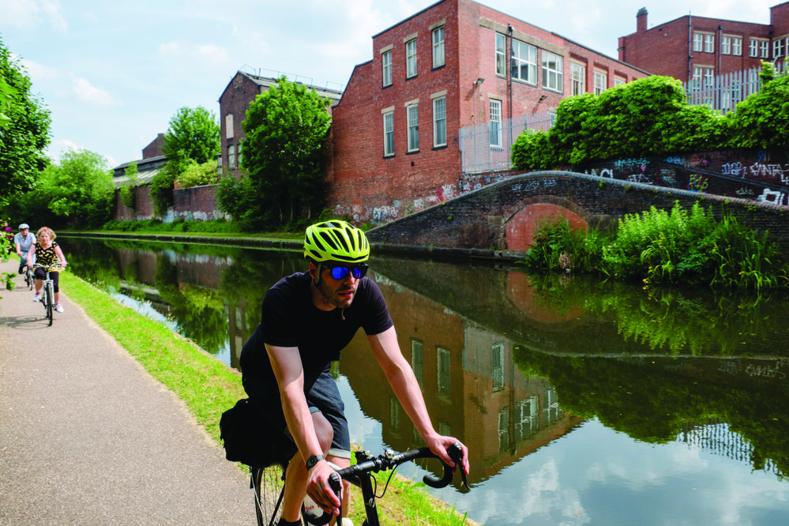

# 6. Materials

## 6.1 Hard landscaping

Where at least 80% of all external hard landscaping and boundary protection (by area) achieves an A or A+ rating, as defined in the Green Guide to Specification. Green Guide ratings for the specification(s) of each element can be found at: [www.thegreenguide.org.uk](http://www.thegreenguide.org.uk)

## 6.2 Responsible Sourcing

A Cradle to Cradle approach should be taken for the key building materials and furnishings that are used. A feasibility study must be done to look at sustainable alternatives and/or the sustainable standards of the building materials being recommended for use. These include of the following:

Building Elements

* Brick (including clay tiles and other ceramics)
* Pavers (concrete, clay)
* Resin-based composites and materials, including GRP and polymeric render
* Concrete (including in-situ and pre-cast concrete, blocks, tiles, mortars, cementitious renders etc.)
* Glass
* Plastics and rubbers (including EPDM, TPO, PVC and VET roofing and other membranes and polymeric renders)
* Metals (steel, aluminium etc.)
* Dressed or building stone including slate
* Stone and gravel
* Timber, timber composite and wood panels (including glulam, plywood, OSB, MDF, chip-board and cement bonded particleboard)
* Plasterboard and plaster
* Bituminous materials, such as roofing membranes and asphalt
* Other mineral-based materials, including fibre cement and calcium silicate

Other Materials

* Soft Flooring
* Partitions
* Glazed Partitions
* Ceilings
* Workstation and tables
* Storage units
* Wall coverings
* Hard flooring
* Countertops
* Joinery
* Raised flooring systems
* Insulation
* Paints and Coatings
* Polishes and Varnishes
* Doors
* Kitchen Fittings
* Hard Wall coverings
* Screed
* Internal Signage
* Furniture

The following should be looked into depending on the specific material, where materials meet at least one of the following:

* the manufacturing content has been made with a portion of recycled material and that it can be recycled at the end of its life;
* a portion of the material has an A or A+ rating on BRE’s The Green Guide to Specification;
* a portion of the material has an A or A+ rating in BRE’s Green Book Live database
* the manufactured content has a portion of renewable/ natural products;
* has a Cradle to Cradle certification;
* are supplied with an environmental product declaration in accordance with ISO 14025 standards;
* is reclaimed (e.g. timber, bricks);
* (timber) archives full Forest Stewardship Council (FSC) or Programme for the Endorsement of Forest Certification (PEFC) project certification; or
* have been awarded the EU Ecolabel (paints)

## 6.3 Insulation

Any new insulation specified for use within the following building elements must be assessed:

* External walls
* Ground floor
* Roof
* Building services

All insulation materials (fire, thermal and acoustic) meet at least one of the following criteria:

1. are natureplus labelled product;
2. composite materials must be able to be separated readily at the end of first use:
   1. are assembled without the use of adhesives;
   2. can be demonstrated that materials can be easily separated now; and
   3. the materials are robust enough to separate and not to disintegrate.
3. are manufactured with at least 50% recycled (measured by mass) and
4. 100% recyclable content that is designed for deconstruction, reclaim and reuse with recyclable components;
5. are manufactured from at least 50% renewable material, e.g. hemp, flax, newspaper, wool;
6. are manufactured with a combination of at least 50% recycled content and 50% renewable material, e.g. hemp, flax, newspaper, wool;
7. 80% of the insulation has an A+ or A rating in BRE’s The Green Guide to
8. Specification;
9. 80% of the insulation has an A+ or A rating in BRE’s Green Book Live
10. database; or
11. are supplied with an environmental product declaration (EPD), written in accordance with ISO 14025 standards.

## 6.4 Robustness

Areas of the building need to be identified (both internal and external) where vehicular, trolley and pedestrian movement occur.

The design should incorporate suitable durability and protection measures or design features/solutions to prevent damage to the vulnerable parts of the building. This must include, but is not necessarily limited to:

* Protection from the effects of high pedestrian traffic in main entrances, public areas and thoroughfares (corridors, lifts, stairs, doors etc.).
* Protection against any internal vehicular/trolley movement within 1m of the internal building fabric in storage, delivery, corridor and kitchen areas.
* Protection against, or prevention from, any potential vehicular collision where vehicular parking and manoeuvring occurs within 1m of the external building façade for all car parking areas and within 2m for all delivery areas.

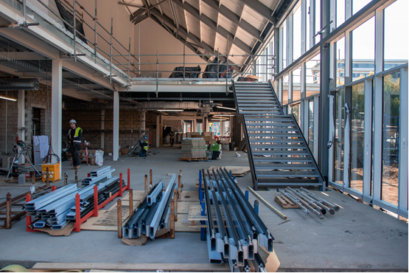

# 7. Waste

## 7.1 Resource Management Plan (RMP)

The construction industry is the UK’s largest consumer of natural resources, sending around 11.6 million tonnes of construction, demolition and excavation waste to landfill annually. More efficient use of materials would be a major contribution in reducing the environmental impact of construction, including reducing demand for landfill and the depletion of finite natural resources.

Contractors must have the appropriate waste management and waste carrier licences and comply with the relevant waste regulations. Any waste transfer notes produced or received by the contractor will include all information required by legislation.

A resource management plan (RMP also known as a Site Waste Management Plan) is prepared prior to site works beginning.

The format of the RMP includes and allows for the projected and actual waste stream volumes or tonnages that will be individually tracked by University.

At least 85% of non-hazardous material removed from the project is diverted from landfill. The total amount of recycled and/or secondary aggregate specified is greater than 25% (by weight or volume) of the total high-grade aggregate specified for the development.

If possible a PAS 402 certified waste contractor should be used. PAS 402 is an externally verified certification that waste contractors can achieve. It provides a methodology for waste contractors to follow, allowing clear and accurate demonstration against key areas of delivery including landfill diversion and material recovery.

The diversion from landfill targets above include reuse, waste recycling and energy recovery. The reuse volumes/tonnages will need to be calculated based on the item’s anticipated waste volume/tonnages.

Returnable reusable packaging is to be used by at least 5 product manufacturers or distributors that are supplying the project.

Where existing buildings or parts of a building on the site will be demolished a pre-demolition audit of any existing buildings, structures or hard surfaces is completed to determine if, in the case of demolition, refurbishment/reuse is feasible and, if not, to maximise the recovery of material from demolition for subsequent high-grade/value applications. The audit must cover:

1. Identification of the key refurbishment/demolition materials.
2. Potential applications and any related issues for the reuse and recycling of the key refurbishment and demolition materials.

Further guidance on Site Waste Management Plans and construction waste can be found in the Safety Code of Practice document and Construction Waste Guidance on the [ECD website](http://www.aston.ac.uk/about/estates/policies/).

## 7.2 Recyclable waste storage space

An operational waste management strategy has been developed in accordance with the departmental/occupational need and provides a dedicated space for storage and is in line with any existing campus wide waste strategy.

Space is provided for the storage of recyclable waste and general waste generated by the occupant’s operations, based on the waste management strategy’s recommendations. This space should:

* be adequately sized in line with the operational activities of the occupant and waste collection frequencies, ensuring it can cover peak occupancy levels;
* be accessible to both building occupants and waste collectors;
* be clearly marked as an area for recycled waste; and
* the size of segregated bins should be consistent with the volumes of operational waste streams generated.

All bins must be approved by Estates and Capital Developments.



# 8. Ecology

An area of concern is around habitat fragmentation and how cities have isolated green spaces either side of them. Making small improvements to our buildings can improve overall biodiversity in the surrounding green areas. Studies have shown the wellbeing benefits of having a green space/stimulating view/outside break out area, and as such promoting the use of a green space where possible will enhance biodiversity and in turn improve aesthetics for staff.

Either a new space for biodiversity is provided in line with the scale of the project or improvements are made to existing green spaces. These can be on any tenant external space including roof or entrance space, balconies, outside breakout areas or surrounding green areas.

Such improvements should be in line with the University’s Biodiversity Policy and its Biodiversity Guidelines (found <www2.aston.ac.uk/environment/strategy-and-policies>) and the University’s Ground Team should be a part of the design process.

A mixture of habitat features and biodiversity enhancements should be considered including:

1. Intensive green roof
2. Intensive brown roof
3. Green wall/ hedging
4. Bids, bat or bug box
5. Brown landscaping

The University’s Ground’s Team should be included in such discussions to make sure any designs meet the aspirations of the team. As described in 1.9 a management plan for the landscaping should be included if appropriate.

## 8.1 Biodiversity Guidelines

The following set of guidelines are to be used in all landscaping work taking place on Aston University’s main campus and Aston’s Recreation Centre. They are also to be taken into consideration for all grounds maintenance work.

The University will endeavor to:

1. Seek to retain and improve existing vegetation and habitats where appropriate;
2. Ensure mature trees are not exchanged for young trees;
3. Ensure any trees moved for development works are either moved to another part of the campus or are replaced;
4. Consider the use of wildflower meadows and tapestry lawns in landscaping designs;
5. Complete the necessary ecology surveys prior to any works commencing;
6. Consider the potential for green walls (external and internal) or green roofs in new developments and refurbishments;
7. Include areas of long grass in selected areas of the campus e.g. the edge of car parks;
8. Select planting that is good for pollinators;
9. Select edible species such as herbs and fruit trees;
10. 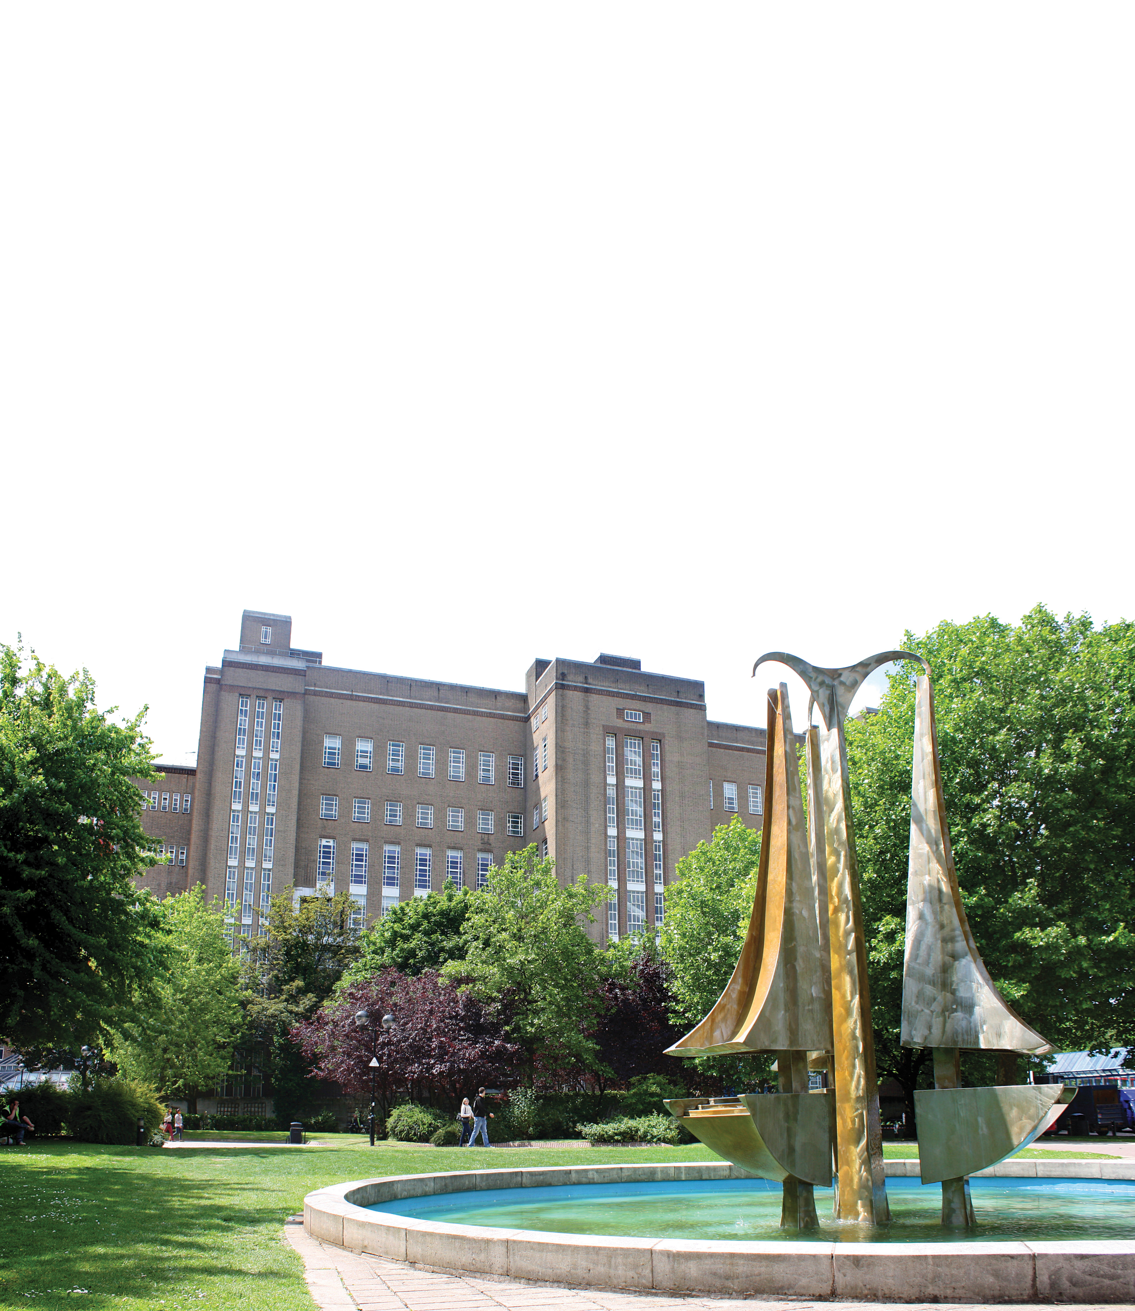Encourage the use of native species;
11. Continue to maintain the green wall on campus;
12. Maintain the lake to encourage a variety of species;
13. Maintain dead wood in secluded areas of the campus, where possible and safe to do so, to create valuable habitats for invertebrates;
14. Check bird boxes on a routine basis and replace them if necessary, and
15. Retain wildlife corridors where possible, in particular ensuring hedgerows are not removed.

# 9. Pollution

## 9.1 Low impact refrigerants

The systems using refrigerants have Direct Effect Life Cycle CO2 equivalent emissions (DELC CO2e) of 1000 kgCO2e/kW cooling capacity.

The Direct Effect Life Cycle CO2e emissions (DELC) per kW of cooling capacity are calculated using the following equation:

(Refrigerant loss operational + refrigerant loss system retirement) × GWP

Cooling Capacity (kW)

Where:

Refrigerant loss operational: (Refchargex Sysop-lifex (L1 + L2 + S1 + S2)) /100

Refrigerant loss system retirement = Refchargex ((1 - RefRecEff)/100)

Where:

1. Refcharge = Refrigerant charge
2. Sysop-life = System operational lifetime (years) - use default value of 10 years
3. RefRecEff = Refrigerant Recovery Efficiency factor (%)
4. L1 = Annual Leakage Rate (units: % refrigerant charge)
5. L2 = Annual Purge Release factor (% refrigerant charge)
6. S1 = Annual Service Release (% refrigerant charge)
7. S2 = Probability factor for catastrophic failure (% refrigerant charge loss/year)
8. GWP = Global Warming Potential of refrigerant
9. Cooling capacity (kW)

In particular system with R32 refrigerant.

## 9.2 Refrigerant leak prevention

Refrigerant systems must be designed to prevent leaks using these standards:

BS EN378-1: 2008+A2:2012 [Refrigerating systems and heat pumps: safety and environmental requirements](http://shop.bsigroup.com/ProductDetail/?pid=000000000030249953)

REAL Zero’s guidance:

* [Designing out leaks: design standards and good practices](https://www.epa.gov/sites/production/files/documents/RealZeroDesigningOutLeaks.pdf); and
* [Guide to good leak testing](https://www.epa.gov/sites/production/files/documents/RealZeroGuidetoGoodLeakTesting.pdf)

## 9.3 Flood risk assessment

A site specific Flood Risk Assessment (FRA) must be provided to confirm the risk of flooding from all sources and confirms to the satisfaction of the local authority and statutory body that the development is appropriately flood resilient and resistant from all sources of flooding.

Where drainage measures are specified to ensure that the peak rate of run-off from the site to the watercourses (natural or municipal) is no greater for the developed site than it was for the pre-development site. Calculations include an allowance for climate change; this should be made in accordance with current best practice planning guidance.

In order to minimise water course pollution it must be confirmed that there is no discharge from the developed site for rainfall up to 5mm. In areas with a relatively low risk source of watercourse pollution Sustainable Drainage Systems (SUDs) or source control systems such as permeable surfaces or infiltration trenches where run-off drains must be specified.

Where present, all external storage and delivery areas designed and detailed in accordance with the recommendations of the Environment Agency’s publication Pollution Prevention Pays Guidance.

## 9.4 Night time light pollution

An external lighting strategy should be designed in compliance with Table 2 (and its accompanying notes) of the ILP Guidance notes for the reduction of obtrusive light <https://www.theilp.org.uk/documents/obtrusive-light/>

All external lighting (except for safety and security lighting) can be automatically switched off between 23:00 hr. and 07:00 hr. This can be achieved by providing a timer for all external lighting set to the appropriate hours or through the University’s BEMS.

If safety or security lighting is provided and will be used between 23:00 hr. and 07:00 hr., this part of the lighting system complies with the lower levels of lighting recommended during these hours in Table 2 of the ILP’s Guidance notes, for example by using an automatic switch to reduce the lighting levels at 23:00 hr. or earlier.

## 9.5 Noise attenuation

A noise impact assessment must be carried out in compliance with BS 4142:2014. The primary professional body for acoustics in the UK is the Institute of Acoustics.

The noise level from the proposed site/building, as measured in the locality of the nearest or most exposed noise-sensitive development, is a difference no greater than+5dB during the day (07:00 hr. to 23:00 hr.) and +3dB at night (23:00 hr. to 07:00 hr.) compared to the background noise level.

Where the noise source(s) from the proposed site/building is greater than the levels described above, measures should be installed to attenuate the noise at its source to a level where it meets these levels.

**Plant noise**

The noise impact assessment must show that new plant will not create a noise level more than 5dB above existing background noise levels or the report provides recommendations for acoustic insulation to ensure that any new installed plant will not create a noise level more than 5dB above existing background noise levels.

# **Refurbishment Project Guidelines**

# Introduction to SKA HE

The Ska Rating is a sustainable refurbishment rating managed through the Royal Institute for Chartered Surveyors. It was designed to promote the principles of sustainable development within the context of the fit-out of an interior environment and it aims to improve the environmental outcomes related to the fit-out. SKA HE focuses on Higher Education specific projects.

The SKA HE assessment tool is publically available by registering [here](https://ska-tool.rics.org/?_ga=2.253695114.2090809570.1562582569-1026237366.1560440000).

The tool is broken up into a series of key areas including:

* Ecology
* Energy and CO2
* Materials
* Pollution
* Project Delivery
* Transport
* Waste
* Water
* Wellbeing

Within these areas there are 131 Scopes based on good practice criteria with free, supporting information explaining the measures that can be taken to meet those criteria.

The University has a target to hit a gold rating for any refurbishment projects over £1 million. Projects under £1 million should look at implementing the SKA HE requirements.

## Large Projects (over £1 million)

For all large projects, a SKA HE assessor is required at the start of the design process. The design team and assessor should work through the project to determine what elements of SKA HE are within the scope of the project.

The design team will then target a GOLD rating by working through all scopes identified and choosing which ones can be achieved to:

* support the environment and staff wellbeing;
* support existing current estates specifications; and
* And does not impact on the project budget.

If there are scopes that need to be met in order to achieve a GOLD rating, but incur additional costs, then a business case must be written that highlights the additional costs required and the benefit of implementation. The approval of this addition will be discussed by the estates projects team.

The agreed scopes to obtain a GOLD rating will be a guideline for the appointed building contractor. They will be implemented in the design stage and then discussed with the appointed contractor. Tendering documents for contractors will include that the project must meet a SKA HE GOLD rating.

If the contract does not meet a scope/s that lead to a project not achieving a GOLD rating, then the will need to implement scopes not targeted at a cost to them in order for a GOLD to be achieved.

A SKA HE assessor must be used to fully certify the project at Design and Handover stages.

## Small Projects (under £1 million)

This document summarises the key areas within small projects that will have a SKA HE scope.

**Materials**

Materials mentioned in the University’s building specifications should look to embed the specifications set out in the sustainable refurbishment scheme SKA HE (Higher Education). More details of each can be sent on request. The following are the main materials that fall within the SKA scheme along with a short description of requirements, where one aspect needs to be met where possible. In most cases there are other criteria that a material could meet, but the ones described below are considered the easiest and are in line with current specifications.

**Timber including Doors and Joinery**

Supplied with a Chain of Custody for one of the following:

* Forest Stewardship Council (FSC);
* Programme for the Endorsement of Forest Certification (PEFC); or
* Grown in Britain (GiB).

**Glazed Partitions and Doors**

Either:

* Are re-locatable (see guidance for definition), and are manufactured in a factory that has achieved and maintains an Environmental Management System in accordance with ISO 1400; or
* Are supplied with an environmental product declaration written in accordance with ISO 14025 standard.

*Supplier/ specific material that meets scope:* Planet Partitioning

**Partitions**

Either:

* Are re-locatable; or
* Are supplied with an environmental product declaration written in accordance with ISO 14025 standard.

*Supplier/ specific material that meets scope:* British Gypsum 12.5mm Sound Bloc

**Internal signs**

Either:

* Are manufactured with materials that have a recycled content; or
* Are modular and can be updated without elements sent to landfill.

**Insulation**

Either:

* Are supplied with an environmental product declaration written in accordance with ISO 14025 standard; or
* 80% of the insulation has an A+ or A rating in BRE’s The Green Guide to Specification.

*Supplier/ specific material that meets scope:* Isover Acoustic Partition Roll APR1200 – 25mm / 50-65mm

**Soft Flooring**

Either:

* Have an A or A+ rating in BRE’s The Green Guide to Specification;
* Have a Cradle to Cradle Silver or higher certificate; or
* Carpets are installed as part of a manufacturer’s recycling or ‘take back’ scheme and are labelled accordingly.

*Supplier/ specific material that meets scope:* DESSO who also offer a free carpet takeback scheme.

**Paints and coatings**

Either

* Have been awarded the EU Ecolabel;
* Have been assessed by Life Cycle Assessment (LCA) and there is a published environmental product declaration (EPD), written in accordance with ISO 14025.

*Supplier/ specific material that meets scope:* ICI Paints AkzoNobel/ DULUX can provide statements for 67 of their paints and most DULUX Trade paint that the University uses meet the requirements.

**Polishes and Varnishes**

All polishes and varnishes meet at least one of the following criteria:

* Are water based – Dulux/ AkzoNobel Diamond varnish meets this requirement.

A further benefit would be to obtain one with a low VOC rating.

Supplier/ specific material that meets scope: Vermeister Zero VOC varnish for wood flooring meets all SKA requirements.

**Ceiling including ceiling tiles or membranes**

Either:

* Are manufactured with materials that have a recycled content;
* Have a Cradle to Cradle Silver or Platinum certificate; or
* Are supplied with an environmental product declaration, written in accordance with ISO 14025 standards.

*Supplier/ specific material that meets scope*: Ecophon Saint-Gobain’s Ecophon Solo range

*NB Armstrong Ceilings offer ceiling tile takeback scheme on their ceiling tiles only.*

**Furniture (Chairs, Tables, Workstations and Storage units)**

Either:

* Have a Cradle to Cradle Silver or higher certificate;
* The company manufacturing the products is certified under the Furniture Industry Sustainability Programme (FISP) scheme; or
* Are supplied with an environmental product declaration, written in accordance with ISO 14025 standards.

*Supplier/ specific material that meets scope:* Furniture provided by Senator typically meet this requirement.

**Screed**

• Supplied with an environmental production declaration (EPD), written in accordance with ISO 14025 standards.

*Supplier/ specific material that meets scope:* ARDEX FA 20 meets the requirements of FEICA EPD Mineral Mortars 2013311 as a LCA Group 2 material.

Other materials that have a SKA HE Good Practice Measure, but aren’t deemed to be used as much for smaller projects, include:

* Bricks
* Screed
* Hardwoods
* Raised flooring systems
* Hard flooring
* Hard Wall Coverings
* Wall covering
* Countertops
* WC cubicle and integrated plumbing systems.

**Low Impact Refrigerants**

For all mechanical systems please see the University’s Mechanical Specification first.

Ideally, Air Conditioning should not be installed unless in specific areas such as IT server rooms, computer labs, and research wet labs. Instead Heat Pumps or VRF ideally with refrigerant R32 If it is installed then then the system being fitted should follow the following SKA HE scope guidance:

The systems using refrigerants have Direct Effect Life Cycle CO2 equivalent emissions (DELC CO2e) of 1000 kgCO2e/kW cooling capacity.

More information on this calculation can be found here.

Our Mechanical Spec identifies only using Mitsubishi, Daikin or Trane DX units. Most types of units from these manufacturer meet the Energy Technology List requirements, which is stated in SKA.

### Appendix 1: Table comparing current University specification with BREEAM ratings.

