LO-C 30
Report Summary

New research reveals language capabilities are a key driver for UK SME export success
Aston Business School researcher Ankita Tibrewal’s influential quantitative research on 415 UK SMEs across different sectors examines their organisational-level language capacity (LO-C) and its drivers through statistical analysis and modelling.
The research reveals that SMEs making use of language capabilities are 30% more successful in exporting than those who do not.
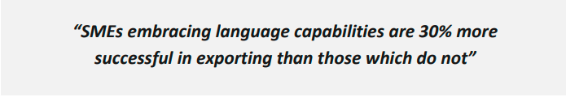
SMEs generate growth through exports
SMEs play a critical role in the UK economy, and their contribution increases year on year. SME companies represent 99.9% of the business population with 6 million businesses and around half of all turnover in the UK’s private sector. SMEs employ 16.8 million people, 61% of the total workforce.
Previous academic research on UK companies has shown a strong link between exporting and growth, and for SMEs a key way to generate growth is through exporting products and services to international markets.
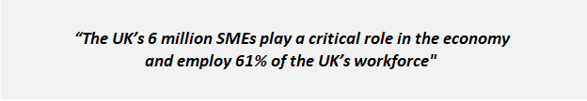
SMEs increase their export sales, growth and profits by investing in language capabilities
The LO-C 30 Report is the first comprehensive, country-wide quantitative research study investigating how language capabilities at an organisational level can facilitate the internationalisation of UK SMEs.
The research analyses the impact of language capacity (LO-C) on companies’ export performance, and identifies key drivers that facilitate LO-C within an SME.
LO-C, a key concept within the research, indicates the company’s motivation, preparedness and attitudes towards developing language-related capabilities, as well as the actual use of available language capabilities.
The results of the research strongly indicate that SMEs can significantly increase their export sales, growth and profits by hiring people with language skills and high cultural intelligence, providing language training to existing staff and investing in professional translation services using sophisticated language technology.
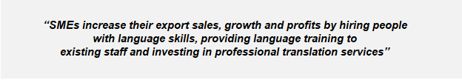
Language capacity (LO-C) and its key drivers and outputs
These activities, identified in the research as Cultural Intelligence, Linguistic Competencies, Willingness to Invest, Training and Technological Awareness, are key drivers for a company’s language capacity.
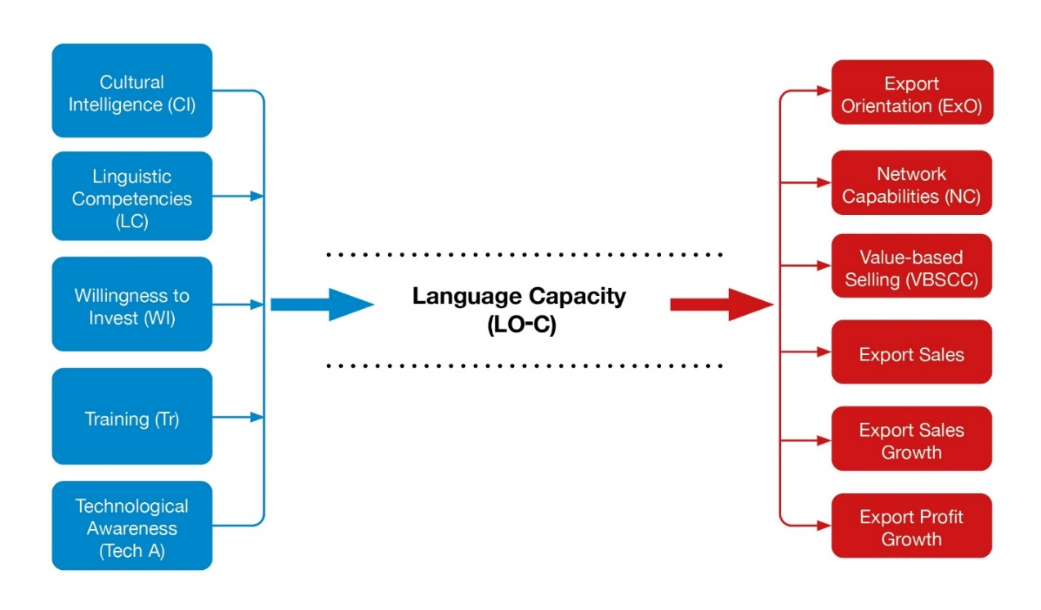
Staff training and willingness to invest in translation and language services are the two most important drivers facilitating LO-C within a company, while staff members’ linguistic competencies and cultural awareness are necessary for LO-C.
LO-C has a strong, direct and positive relationship with export orientation which refers to the company generating, responding to or disseminating export intelligence and analysis for international markets.
LO-C also has a significant direct relationship on export sales, growth and profits, as well as the company’s networking capabilities and value-based selling activities, indicating that SMEs embracing language capabilities are more successful in exporting than those who do not.
LO-C 30 Report, Ankita Tibrewal, Aston Business School 2021
Research funded by Aston University and the Association of Translation Companies
Aston Centre For Growth
Aston Centre for Growth offers leading growth programmes and other opportunities for SME owners looking to grow their business. Aston Centre for Growth works with SMEs to support their business growth, with investment ready pitching competitions, through its student focused start-up support and incubation centre and on high profile programmes such as Goldman Sachs 10,000 Small Businesses.
https://www2.aston.ac.uk/aston-business-school/business/centre-for-growth

Association of Translation Companies
Language services, translation and interpreting drive global growth and support UK companies’ internationalisation activities. The Association of Translation Companies is the leading voice for companies operating in the UK’s language services industry. ATC membership is recognised as a mark of quality-managed service, and the ATC’s Member Directory lists language service companies offering translation and interpreting in all sectors and languages.
https://atc.org.uk/member-directory

