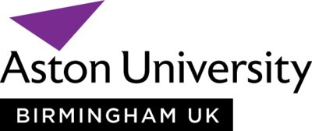

Pakistan Entry Criteria September 2023 and January 2024

British Degree Equivalents | First | 2.1 | 2.2
Pakistani Universities
Tiers
Tier 1 | 70% or a CGPA of 3.0 | 60% or a CGPA of 2.8 | 55% or a CGPA of 2.6
Tier 2 | CGPA of 3.2 | CGPA of 3.0 | CGPA of 2.8
Tier 3 | 90% or CGPA of 3.6 | 80% or CGPA of 3.4 | 70% or a CGPA of 3.2

Tier 1
- Dow University of Health Sciences (Karachi)
- Giki (Ghulam Ishaq Khan Institute of Engineering Sciences and Technology)
- Institute of Business Administration (IBA) (Karachi)
- Lahore University of Management Sciences (LUMS)
- Nadirshaw Eduljee Dinshaw University of Engineering and Technology Karachi (NED Karachi)
- National College of Arts Lahore (NCA)
- National University of Science and Technology (NUST) (Islamabad)
- Pakistan Institute of Engineering and Applied Sciences (PIEAS) (Islamabad)
- Quaid-i-Azam University (Islamabad)
- University of Engineering and Technology (UET) (Lahore)

Tier 2
- Air University (Islamabad)
- Bahria University (Islamabad)
- COMSATS University (Islamabad campus)
- FAST National University of Computer and Emerging Sciences (Islamabad)
- Forman Christian College (FC College) (Lahore)
- Iqra University (Karachi)
- Lahore School of Economics (LSE)
- University of Lahore (UOL)
- SZABIST (Shaheed Zulfiqar Ali Bhutto Institute of Science and Technology) (All campuses)

Tier 3 - Universities whose name doesn’t feature above

For more information contact Hristina Dimova, International Student Recruitment Officer at h.dimova1@aston.ac.uk

