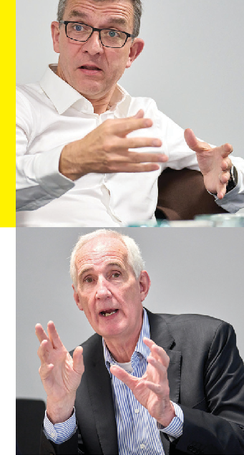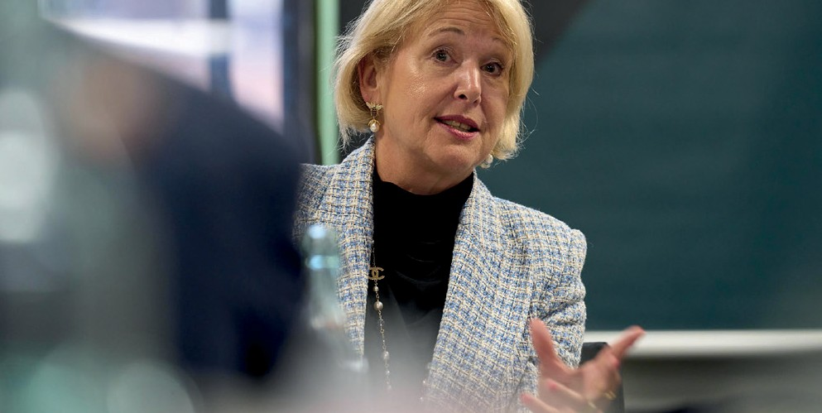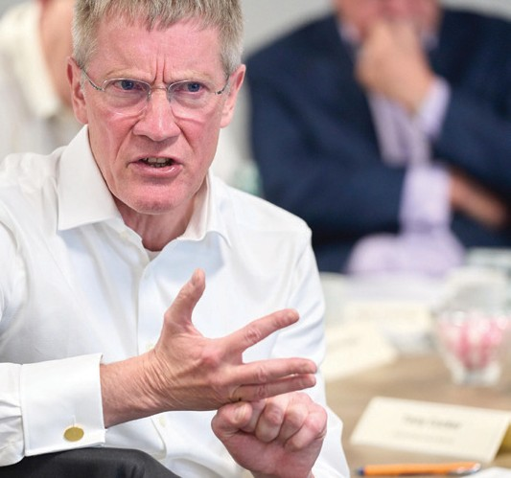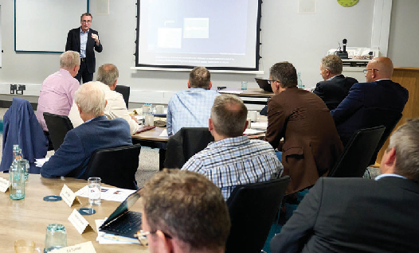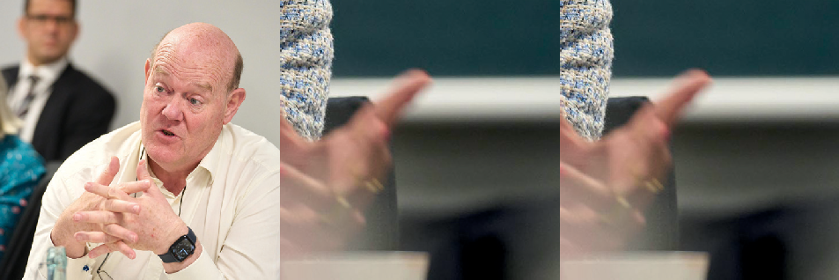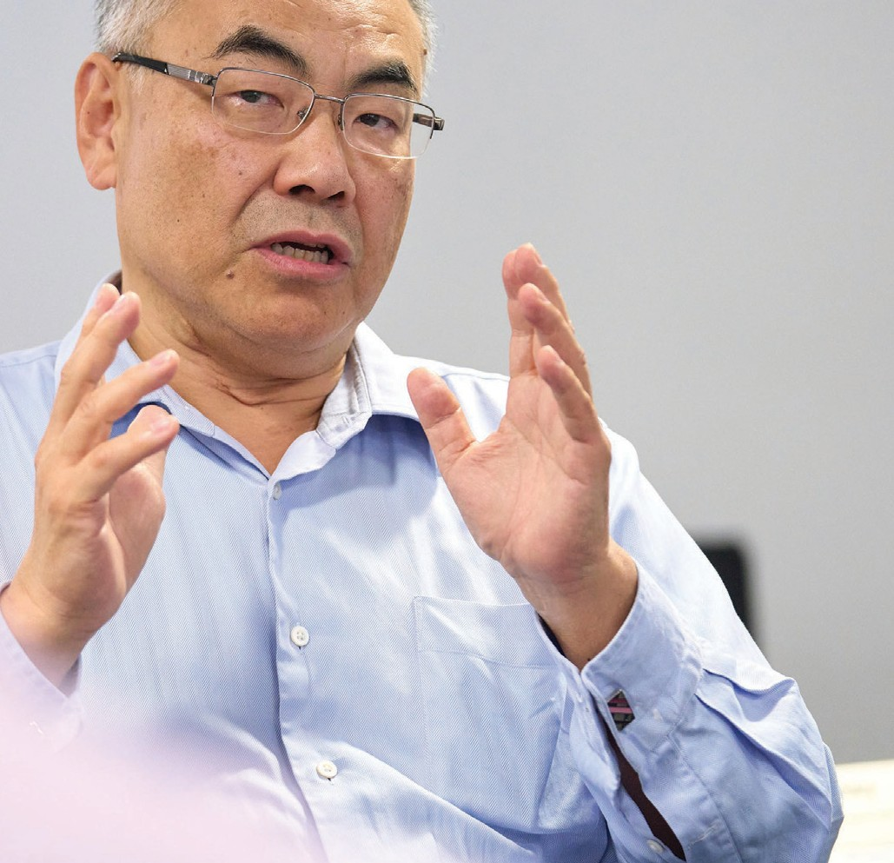

Visiting Professors

From the boardroom to the classroom

Visiting Professors
From the boardroom to the classroom

Aston University has invited some of the UK’s leading business leaders to become Visiting Professors and share their vast experience with our students, staff and the local business community.

They will help us to understand the critical challenges affecting organisations and provide us with unique insights into what they look for in students and graduates taking their first step on the career ladder and with ambitions to become business leaders of the future.

We are grateful to all of our Visiting Professors for giving up their valuable time and sharing their personal experiences.

Visiting Professors

Professor Sir Rod Aldridge

Former Chairman, Capita Group
Sir Rod is one of the UK’s leading social and business entrepreneurs with a career that has spanned senior roles in the public sector, business and the voluntary sector.
His career started in the public sector, where he qualified as a Chartered Public Accountant during working for four local authorities and then joined the secretariat of the Chartered Institute of Public Finance & Accountancy where he became its Technical Director.
Rod went on to found the Capita Group, which he built from a start-up in 1984 to a FTSE 100 company that today employs over 60,000 people. Capita shaped the outsourcing market in the UK.

Professor Rooney Anand

Executive Chairman at RedCat Pub Company (Former Chief Executive Officer (CEO), Greene King)
Rooney Anand is Executive Chairman of RedCat Pub Company, backed by Oaktree Capital;
he is also Chairman of private equity backed businesses Away Resorts and Purity Soft Drinks.
He served as Senior Independent Director for Wm Morrison Supermarkets plc for six years prior to its sale to CD&R in October 2021.
Rooney was Chief Executive Officer (CEO) of Greene King plc for fourteen years from 2005 to 2019. Before becoming CEO he was appointed to the board of Greene King plc in 2001 as the Managing Director of the company’s brewing division.
Prior to joining Greene King, Rooney built a marketing career in consumer goods at Sara Lee Corporation and before that with United Biscuits plc where he started his executive career after completing his MBA at Aston Business School in 1988.

Professor Tony Hayward

Founder, Chairman and Chief Executive Officer (CEO), Energy Transition Partners
Tony is the Founder, Chairman and Chief Executive Officer (CEO) of an Amsterdam listed SPAC focussed on energy transition. He is Founder and Executive Chairman of SierraCol Energy, Colombia’s largest independent oil company. He is also a Managing Partner of Energy Transition Partners LLP, a Board Member of the Bahrain Oil and Gas Holding Company Nogaholding and assumes the role of Non-Executive Chairman of CC Energy in June 2023.
Tony was Chairman of Glencore from 2013-2021 and Group Chief Executive of BP from 2007 to 2010. He joined BP in 1982 as a Rig Geologist in the North Sea and became Group Treasurer in 2000, Chief Executive for BP’s E&P Business and a member of the Main Board of BP in 2003.
In 2011 Tony founded Vallares plc, a $2.2bn SPAC listed on the London Stock Exchange. Following the merger of Vallares plc and Genel Energy he became Chief Executive in November 2011 and subsequently Chairman (2015-2017).
Tony studied Geology at Aston University in Birmingham and completed a PhD at Edinburgh University. He is a Fellow of the Royal Society of Edinburgh, chairs Aston University Development Board and helped found Ocean Leadership Programme at Edinburgh University.

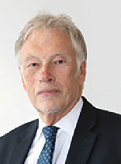Professor Lord Bichard

Crossbench Peer, House of Lords
Michael George Bichard, Baron Bichard KCB is a former public servant in the United Kingdom, first in local and then as a civil servant in central government. He was Director of the Institute for Government, currently serves as one of its first fellows, and was Chair of the Design Council.
He was a created a crossbench life peer in March 2010. He is an advisor to The Key Support Services Limited, which provide leadership and management support to school leaders and governors. He became chair of the Social Care Institute for Excellence (SCIE) in 2013. He has chaired the National Audit Office, served as Vice Chancellor of the University of the Arts and was Permanent Secretary to the Department for Education and Employment.

Professor Tony Cocker

Independent Non-Executive Director and Chair, SSE plc
Tony Cocker was the Chief Executive of E.ON UK, one of the UK’s largest energy providers. He is also a chair of Infinis Energy Management Limited’s board.
Tony Cocker is an independent Non-Executive Director. He is currently Senior Independent Director of SSE plc (the FTSE listed energy business), Chair of Infinis Energy Management Ltd (a leading distributed power generator), as well as recently becoming a Visiting Professor at Aston University. He was previously Chair of Affinity Water Ltd (the largest water-only supplier in the UK), Chair of the EIC (a not-for-profit organisation linking energy network companies to SME innovators), and deputy Chair of the Warwick Independent Schools Foundation.
In his executive career, Tony worked for E.ON SE and Powergen in a number of roles from 1996-2017, including Chair and CEO of E.ON UK plc. Prior to joining Powergen, Tony had worked for Bass Plc and LEK Consulting.
Tony has an MBA from IMD in Lausanne and a BA and D.Phil in Mathematics from Oxford University.

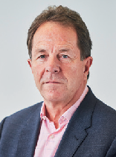Professor Peter Cheese

Chief Executive Officer (CEO) Chartered Institute of Professional Development (CIPD)
Peter is the Chief Executive Officer (CEO) of the CIPD, the professional body for HR and People Development. Since January 2019, he has been co-chair of The Flexible Working Task Force, a partnership across government departments, business groups, trade unions and charities, to increase the uptake of flexible working. He is also Chair of Engage for Success and the What Works Centre for Wellbeing.
Peter writes and speaks widely on the development of HR, the future of work, and the key issues of leadership, culture and organisation, people and skills. In 2021, his second book ‘The New World of Work’ was published, exploring the many factors shaping work,
workplaces, workforces and our working lives, and the principles around which we can build a future that is good for people, for business and for societies.
Prior to joining the CIPD in 2012 Peter was Chair of the Institute of Leadership and Management, an Executive Fellow at London Business School, and held several Board level roles. He had a long career in consulting at Accenture working with organisations around the world, and in his last seven years there was Global Managing Director for the firm’s human capital and organisation consulting practice.
He is a Fellow of the CIPD, a Fellow of the Australian HR Institute (AHRI), the Royal Society of Arts (RSA), and the Academy of Social Sciences. He’s also a Companion of the Institute of Leadership and Management (ILM), the Chartered Management Institute (CMI), and the
British Academy of Management (BAM). He holds honorary doctorates from Bath University, Kingston University and Birmingham City University, and is a Visiting Professor at Aston University.

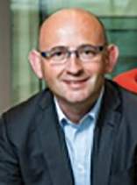Professor Gary Coombe

Chief Executive Officer, Global Grooming Business, Proctor and Gamble, Aston University alumna
Gary Coombe is Chief Executive Officer (CEO) of P&G’s Global Grooming business, including the biggest shaving brands in the world - Gillette, Venus, Braun, Joy and The Art of Shaving. The grooming business is responsible for 10% of total company revenue ($6.5BN), serving nearly 800 million consumers around the world.
Since joining P&G in 1986, Gary has been at the heart of the consumer goods industry including regional and global leadership roles in two of P&G’s biggest categories: Fabric Care and Home Care. Gary was also responsible for global innovation and new business development on P&G’s Fabric and Air Care businesses, leading the creation of the Tide Dry
Cleaners franchise, growing Febreze to billion-dollar-brand status and leading the acquisition of Ambi Pur. Appointed President of Europe in 2014, Gary was responsible for one-third of P&G’s global workforce and a quarter of total company sales and profit.
Gary is passionate about coaching the next generation of leaders in and outside of P&G.
He advocates servant leadership and dedicates much of his time to coaching, leadership training, and guest-lecturing at universities. He is an active champion for diversity & inclusion, acting as executive sponsor for P&G’s Gender Equality and LGBT+ affinity groups.

Professor Matthew Crummack

Chief Executive Officer (CEO), Domestic & General Group PLC
Matthew Crummack is an experienced executive having led the transformation of big consumer-facing digital brands across different geographies. He has worked with companies including GoCompare, lastminute.com, Expedia, Nestlé and Procter & Gamble.
From 2016 Matthew was the Group CEO of financial and home services business GoCo Group plc prior to its sale in 2021 to Future plc for $794m. He led the company’s growth through transforming the UK price comparison website GoCompare.
Prior to that, Matthew was the CEO of lastminute.com Group from 2011 where he led the turnaround of the business prior to its sale to Bravofly Rumbo Group for $120m in 2015 when he became Deputy CEO and Chief Integration Officer during the transition.
Previously he was Senior Vice President of Lodging at Expedia, instrumental in building Expedia’s hotel inventory and price competitiveness, particularly in Europe where the company faced significant competition in its hotels business. Prior to Expedia Matthew was Global Business Development Director for Nestle UK, and started his career in sales and marketing in the UK and Europe with Procter & Gamble where he worked on the European expansion of brands such as Pringles and The Iams Company.
Matthew is also an Aston University alumnus and is on the Aston University Council.

Professor Deborah Leary

Founder and Chief Executive Officer (CEO) of Forensic Pathways
Deborah is Chief Executive Officer (CEO) and Founder of Forensic Pathways, an international consultancy and technology design company specialising in the development of innovative technologies for the criminal, threat intelligence and business intelligence arena. Over the past 22 years, Forensic Pathways has been at the forefront of innovation with the company being successful in a range of innovation funding bids. This has included Innovate UK Funding in May 2022 for their Linguistically Enabled Analytic Dark Search Engine (LEADS- Engine) with academic partners Aston University.
Deborah is an international motivational speaker and consultant on entrepreneurship and innovation, international trade, and corporate social responsibility. In 2022 she was made a Visiting Professor of Aston University and in addition holds an Honorary Doctorate from
Birmingham City University. In 2008 she was presented with the Order of the British Empire (OBE) for Entrepreneurship and the Community.
She is currently President of the Greater Birmingham Chamber, only the third woman President since 1813.

Professor Alison Endemaño

Managing Director, Oaktree Capital Management
Alison Endemaño has over 20 years of private equity experience and is currently Managing Director within the European Principal Group at Oaktree Capital Management, a global alternative investment management company.
Her career started at Arthur Andersen where after qualifying as an ACA she joined their newly formed Human Capital consulting division. From there she moved to 3i, Bausch & Lomb and Ramboll before joining Oaktree Capital Management in 2013.
In her current role, Alison advises on a variety of strategic and operational areas including board and executive team composition, organisational design, culture, talent management, remuneration strategies and D&I. She also provides individual coaching support to C-suite leaders and members of their teams.
Alison currently holds several board positions including Atomos Wealth, Lifestory Group, Specialist Lending (Duologi) and ProService Finteco. She is also an experienced Remuneration Committee Chair. Previously board positions included NED at Ascot Lloyd and Arcade Beauty.
Ms. Endemaño is both a Fellow of the Institute of Accountants in England & Wales and a Chartered Fellow of the CIPD. She is married with three adult children.

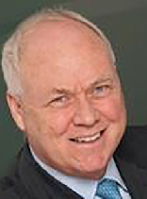Professor Andrew Fisher

Chair, Aquitaine Group Ltd
Andrew has over 30 years of experience in the financial services industry. His career started in marketing with Unilever. He then joined Coopers & Lybrand as a Partner in their strategy consulting practice. From there he moved to Standard Chartered Bank, working in Hong Kong as Commercial Director. He has held several senior executive positions, most recently as CEO of Towry plc. Prior to this, Andrew was CEO of Cox Insurance plc and Coutts & Co Bank. He has also served as a Director of Hoare & Co Bank and Smith and Williamson Wealth Management plc.
Currently living in Switzerland, Andrew is Chairman of Aquitaine Trust and Skerritts Wealth Management. He is a founder and ongoing supporter of the CHASM initiative at Birmingham University and Finance Governor of Sandhurst School, part of the Corvus Academy Trust.

Professor Ann Francke

Chief Executive Officer (CEO), Chartered Management Institute
Ann Francke is Chief Executive of the Chartered Management, Institute the UK’s leading professional body for management and leadership with a global member community of over 170k. She started her career at Procter & Gamble and has held senior executive positions at Mars, Boots, Yell and BSI. In 2020, Ann was awarded an OBE for services to workplace equality.
Ann is an expert on gender balance in the workplace and speaks frequently in the media and conferences on this and other management topics. Her book on gender balance - Create
a Gender-balanced Workplace was published in September 2019. Ann also published ‘Financial Times Guide to Management’ and has been named in the top 100 women to watch in the 2015 Female FTSE Cranfield report. She was awarded the MemCom award for
outstanding leadership of a UK professional body in 2016. Ann is also featured on female one zero’s 2022 list - ‘40 Over 40 – The World’s Most Inspiring Women’
Ann has five Honorary Doctorates for her work in management and leadership and is an advisory board member for the Work Foundation & Nottingham Business School, sits on the Advisory Council of the Chancellor’s Help to Grow: Management initiative, is an Engineering Council Board member, chairing their diversity & inclusion working group and chairs the WACL working group on workplace equality. She has also previously served on commercial boards - Grant Thornton and Tongal.

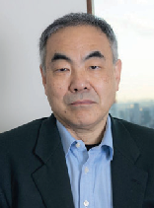Professor Koji Fusa

Chief Executive Officer (CEO), GVE ltd
Koji Fusa is currently a Visiting Professor at The Cyber Security Innovation Centre at Aston University.
He is an experienced serial entrepreneur in the information technology and services industry. He is skilled in venture capital, asset management, fund of funds, equities, and capital markets.
He graduated from WASEDA University with a bachelor’s in engineering. At the age of 38 years old he became a CEO of UBS’s bank subsidiary in Japan. He incubated and has assumed the Chief Executive Officer for GVE Ltd. The company was established in
November 2017 and is valued at $1.7 billion (Yen224 billion) as of April 2022. He contributed to the growth of Japan’s mergers and acquisition market and the capital market in 1990s. He created the global top forex technology company in 2006 called Emcom after an acquisition.

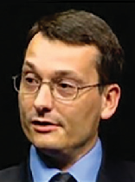Professor Andrew Harrison

Managing Director, DFS Consulting Ltd, Former Engineering Associate Fellow - life cycle engineering, Rolls-Royce plc
Andrew has been a leading figure for 15 years in Rolls-Royce’s ongoing development of advanced services offerings. He is an expert in how services requirements and principles should inform the design and engineering of aircraft engines in order to both optimise the service delivery to customers and also make the provision of services profitable and sustainable for the manufacturer.
Professor Harrison works closely with the Advanced Services Group at Aston Business School and the group’s Advanced Services Partnership. The Partnership is an exclusive network that provides research, tools, events and networking to like-minded business executives in the early stages of implementing services in a manufacturing business.

Professor Simon Hepburn

Chief Executive Officer (CEO), UK Cyber Security Council
Simon Hepburn is a 25-year veteran of the charity, education and careers sector and current Chief Executive Officer (CEO) for the UK Cyber Security Council.
Having previously been Chief Executive of a charity and founded two others, Simon has also held director positions with a variety of national and international charities, academy trusts and businesses. He was also a Trustee Board member of ACEVO (Association for Chief Executives of Voluntary Organisations), was an Enterprise Advisor for the Greater London Authority and has also sat on the BBC Charities Advisory Board.
Simon is an active member of the CyBOK (Cyber Body of Knowledge) Steering Group and the Cyber Growth Partnership Group to ensure that the work of Council is informed and informing the wider cyber security profession.
Through his work experience Simon has developed an impressive network of contacts with colleagues at all levels in organisations and Government.
Simon is passionate about making a positive impact on society and making a difference to the lives of young people and adults supporting them to be the best versions of themselves.

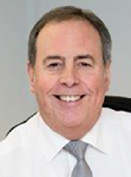Professor Paul Jennings

Principal, ANSENresearch, Former Chief Executive Officer (CEO), JCB Finance Ltd
Paul has worked in managerial jobs for JCB Finance Ltd for over 40 years. He worked his way up to Managing Director and then became Director at Finance & Leasing Association. He has also received a Fellowship and the Sir Henry Fildes Award from the Chartered Management Institute. Currently, Paul is a Visiting Professor in the College of Business and Social Sciences at Aston University and has a Level 7 Executive Diploma in Management.

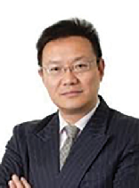Professor Charles Q Li

Chief Executive Officer (CEO), ANZ China
Dr Charles Li is an eminent veteran international banker. He was Chief Executive Officer (CEO) for China at Australia & New Zealand Bank (ANZ) between 2011 and 2014, responsible for all ANZ businesses in China. Under his leadership, ANZ China became one of the major players in facilitating trade and investment flows in the Asia Pacific region.
Before joining ANZ, Dr Li spent 17 years with the Royal Bank of Scotland Group (RBS), holding a series of senior positions in London, Hong Kong, Beijing and Shanghai. Dr Li was instrumental in formulating and implementing RBS’s strategy in China and building RBS’s businesses from representative offices to a fully-fledged locally incorporated bank in China. When he left RBS in 2011, he was Country Executive China at RBS, responsible for all RBS’s businesses in China. During his tenure at RBS China, he also played a key role in initiating and implementing a series of landmark strategic projects, such as strategic investment
into Bank of China, integration of ABN AMRO businesses in China into RBS and oversight of non-banking joint ventures such as Suzhou Trust and Galaxy Futures. Under his stewardship, RBS was recognized as a leading foreign bank in China, making significant contribution to the development of financial markets and banking reforms in China.
Dr Li left his full time banking role in late 2014 to undertake a portfolio of non-executive and advisory roles in commercial and non-profit organisations, including Independent Director of the House of Fraser Group, IDT International (HKEX 167) and the Great Britain China Centre. He currently serves as an Independent Director on the Board of Banque Internationale à Luxembourg S.A. – a systematic important institution in the Euro zone.
Charles completed his undergraduate study in Mechanical Engineering at Beijing Institute of Technology. He holds a MSc in Industrial Management from University of Birmingham and a PhD in Strategic Management from Aston Business School. He is a Fellow of the Hong Kong Institute of Directors.

Professor Martin McCourt

Investor, Non Executive Director, COMPO
Martin McCourt has spent over 40 years working at the heart of British-based manufacturing, design and marketing for quality brands such as Dyson, Mars, Duracell, Toshiba and Pelikan.
Martin was the Chief Executive Officer (COE) of Dyson for 15 years, the ideas to market-leading consumer products maker. As CEO, he devised and implemented a strategy that transformed the company from a single product, single market producer into one where 80% of the business came from over 60 markets around the world. In that time he increased UK skilled jobs, grew profits to over £300m and enabled James Dyson to keep on inventing. In 2011 Dyson hit £1 bn revenue for the first time. Martin was directly responsible for the establishment of Dyson subsidiaries in the USA, Japan, Switzerland, Austria and Germany. In total he took Dyson into over 60 markets, achieving market leadership in the majority including the USA.
Martin’s previous experience was in sales and marketing with successful global companies Mars, Duracell, Toshiba and Pelikan.
In 2010 Martin was named UK Business Leader of the Year.

Professor Claire Miles

Chief Executive Officer (CEO), MAC II Ltd, Yell
Claire began her career in the insurance industry as a Data Scientist, before spending a few years in data and insight consultancy at both CACI and Dunnhumby, supporting their financial services customers. She then led and developed credit card businesses for HSBC, GE Money, and Santander before joining the energy industry at Centrica. At Centrica, she led several different P&Ls and operating divisions over a period of nine years which included being MD
of British Gas Energy Efficiency, MD for HomeCare, MD for Centrica UK Customer Operations and culminating as MD of Hive.
Claire joined Yell as CEO in October 2019, after the conclusion of its print to digital migration. She has stabilised the business, restructured the balance sheet and implemented a new strategy to evolve its digital platform and return the business to growth. Claire’s latest appointment is with Fintech start-up company, MAC II Ltd, as their Interim CEO.

Claire has held various non-Executive Director positions in the private and public sector and is currently on the Board of Biffa Plc where she is Chair of the Remuneration Committee.
She studied Mathematics at Aston University and has an MSc in Mathematical Modelling from Cranfield.

Professor Louise Oliver CFPTM Chartered MCSI FRSA

President of the British Association of Women Entrepreneurs Director/Co-Founder, Piercefield Oliver
Louise is co-founder of Piercefield Oliver, a successful Cheltenham based financial planning firm.
Having headed up several women entrepreneurs groups since 1991, in 2019 Louise was appointed to the role of UK President of the British Association of Women entrepreneurs (BAWE), which is a member of FCEM, the largest international women entrepreneurs group in the world, with 120 member countries. Louise has represented the UK on behalf of BAWE internationally. The membership is for women who have considerable experience in
running their own businesses. BAWE is a network for women focused on optimising business opportunities including international trade and spans most sectors.
Throughout her career she has been a go to financial expert for the media, including BBC breakfast TV, BBC radio 4 Moneybox, a regular panellist for GB news and local radio.
Louise also appeared as an expert for a BBC Panorama programme which delved into the investment advice provided by the major high street banks.
Awards include Female Financial Adviser of the Year and Role Model of the Year in Financial Services.

Professor Leo Quinn

Group Chief Executive (CEO), Balfour Beatty plc
Leo Quinn was appointed to the Board of Balfour Beatty as Group Chief Executive in January 2015, returning to the company where he started his career as a civil engineer.
He joined Balfour Beatty following five years as Group Chief Executive of QinetiQ Group plc and five years as CEO of De La Rue plc. He led both companies through successful transformations which restored each business to strength and created over £1bn of value.
Prior to that, he spent almost four years headquartered in the US as COO of Invensys plc’s
$3bn Production Management division. He also worked with Honeywell Inc for 16 years in various senior management roles across the US, UK, Europe, the Middle East and Africa, ending as Global President of H&BC Enterprise Solutions.
In 2013, he founded The 5% Club which encourages companies to invest in the next generation and address the national skills shortage. Its aspiration is for at least 5% of employees to constitute either apprentices, interns or graduates in formal training programmes.
He was educated at Portsmouth University and Imperial College, London.

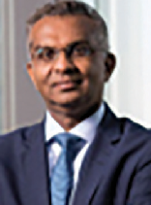Professor Viswas Raghavan

Chief Executive Officer (CEO), J.P. Morgan in Europe, the Middle East and Africa
Viswas Raghavan is Chief Executive Officer (CEO) and member of the Board of J.P. Morgan Securities Plc, J.P. Morgan Europe Limited and Chairman of the London Branch of J.P. Morgan Chase Bank, N.A.
He joined J.P. Morgan in 2000 from Lehman Brothers, initially to head up its equity-linked and derivatives capital markets business for Europe and Asia.
He has since held various senior jobs at the bank, including Head of International Capital Markets and Global Head of Equity Capital Markets.
He grew up in India and studied Physics at the University of Bombay before completing an undergraduate degree in Electronic Engineering and Computer Science at Aston

University. He also qualified as a Chartered Accountant with Ernst & Young, and it was then that he started thinking about a career in investment banking. While at Aston University, he worked as a Systems Engineer at General Signal’s European headquarters in Birmingham and in 2016, he was awarded an honorary doctorate in science from Aston University.

Professor Xavier Rolet

Chief Executive Officer (CEO), World Quantum Growth Acquisition Corporation
Xavier R. Rolet is a French businessman and the chairman and Chief Executive Officer (CEO) of World Quantum Growth Acquisition Corporation, a NYSE-listed company. He was CEO of CQS until January 2020, and before that, CEO of the London Stock Exchange Group.
Named as one of the 100 Best CEOs in the World in the 2017 Harvard Business Review, Xavier has a demonstrated history of successful turnarounds in the global financial services industry. In his decade at the helm of the London Stock Exchange, the LSE’s market valuation rose from £800m to more than £15bn, transforming it into one of the world’s largest exchanges by market capitalisation.

Professor Rupert Soames

Former Chief Executive Officer (CEO), Serco plc
Rupert Soames is an experienced Chief Executive Officer (CEO) having held the role for nearly 20 years in other companies before joining Serco as Chief Executive in 2014.
He studied Politics, Philosophy and Economics at Oxford University, where he is now a visiting fellow, and was President of the Oxford Union.
He was previously Chief Executive of Aggreko plc and the Banking and Securities Division of Misys plc and Senior Independent Director and a member of the Remuneration, Nomination and Audit Committees of Electrocomponents plc.

Professor James Timpson

Chief Executive Officer (CEO), Timpson
James has been Chief Executive Officer (CEO) since 2002, helping the business grow to over 2100 shops, and developing several innovative ways to run the business at a time when traditional High Street retailing has suffered.
James pioneered the recruitment of ex-offenders, to the extent that Timpson now employs over 600 prison leavers (this is over 10% of the company). James is Chair of the Prison Reform Trust and supports various prison charities and support groups, and was presented with an OBE in 2011 for the training and employment of disadvantaged people.

Professor Carmen Watson

Chairperson, Pertemps Network Group
Carmen has over over 30 years’ experience in recruitment and is currently chairperson of Pertemps Network Group, a £1bn turnover operation.
She has steered the business through two recessions and implemented a strategy for growth which saw turnover increased tenfold with customer service at the heart of
recruitment solutions services. She is responsible for promoting and delivering best practice in the field of attraction, recruitment and retention of talent on behalf of clients ranging from SME’s to blue chip organisations, servicing both the public and private sectors across the UK.
Carmen has risen through the ranks of the business, having joined Pertemps as a Secretary in the 70’s and at the age of 24 running a £5 million turnover branch in Wolverhampton.
Joining the Board at the age of 30 Carmen believes passionately that the UK’s service based economy must be supported by a strong under belly of good talent management practices.

An active Board member of Race for Opportunity Carmen is a strong advocate for equality, diversity and inclusion in the workplace and as well as heading up the ED & I committee within Pertemps she works proactively with external customers to help them achieve their objectives.
Carmen received an honorary doctorate from Aston University in 2022 for her contribution to the development of employment opportunities for people from all sectors in the community.

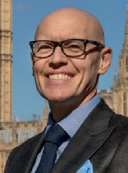Professor Marco Forgione

Director General, Institute of Export & International Trade (IOE&IT)
Graduating from the London School of Economics (LSE) with a degree in Geography, Marco was initially involved in a Parliamentary role within the Department of Environment & Urban Affairs. He took his experience and moved into the education sector helping transform the non-statutory funded provision at Canterbury College including apprenticeships and training programmes.
In 2008 Marco was appointed as Chief Executive Officer (CEO) of the International Visual Communication Association (IVCA), where he established the association as a key partner for the UK government, leading trade missions to UAE, Qatar, China, Germany, and India. His next role was as Chief Executive of the British Antiques Dealers’ Association (BADA), representing world leading art and antiques dealers. He led the association through legal
and regulatory changes and navigated the transition to online. Marco’s combined knowledge of imports/exports together with his experience in education led Marco to the Institute of Export & International Trade (IOE&IT), where he was appointed Director General in January 2020. The Institute has grown from a team of twelve to now over 160 international trade and customs experts, with membership growing from 2,000 to 7,000. IOE&IT is now a trusted partner for governments, international agencies, global businesses and Ministry of Micro, Small & Medium Enterprises (MSME) on every continent. In 2022 IOE&IT opened its first international office in Kenya with plans to further invest in support of The African Continental Free Trade Area (AfCFTA) and the global trade agenda.

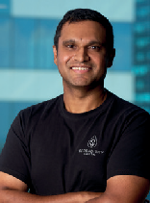Professor Robert Jesudason

Founder of Serendipity Capital
Rob founded Serendipity Capital in 2020 and serves as its Chief Executive Officer (CEO). Serendipity Capital is an independent financial advisory firm that invests in companies that are focused on some of the key disruptive trends in the industry such as artificial intelligence (AI), Blockchain, Quantum Computing and climate change.
Prior to founding Serendipity Capital, Rob was President of Block One, a leading global blockchain company. He was named in the top 100 Global Blockchain Leaders in 2019 and Asian FinTech Top 100 in 2016.
Rob has also held the position of Group Executive and Chief Financial Officer of Commonwealth Bank of Australia (CBA), where he was a member of its Executive Committee.
Previously, he was Group Executive, International Financial Services at CBA, responsible for CBA’s retail and SME banking, digital banking and insurance businesses in China, India, Indonesia, Vietnam and South Africa.
He joined CBA in 2011 as Group Executive, Strategic Development, where he was responsible for Strategy, Mergers & Acquisitions, and the Group Productivity Programme. Prior to CBA, Rob was at Credit Suisse from 2007 to 2011 as Head of Global Emerging Markets within the Financial Institutions Group (FIG) investment banking practice, where he oversaw Financial Institutions coverage teams across APAC, CEEMEA and Latin America. He was named as Asian FIG M&A advisor of the year in 2008.
Earlier in his career, Rob was a Managing Director in the Asian Special Situations Group at JP Morgan as well as Managing Director and Global Head of Corporate Development at Barclays PLC. He also worked for McKinsey & Co and GE Capital.
Rob also holds a Bachelor of Science degree from Aston University and was awarded an Honorary Doctorate in Business Administration from Aston University in 2022.

Aston University Birmingham
B4 7ET

+44 (0)121 204 4910
www.aston.ac.uk

