Coaching Culture Platform
Imagine a world where…
…you had development solutions at your fingertips, wouldn’t that be great? To have the opportunity to reflect on a specific need and self-coach to identify a way forward? Well, look no further.
Organisational Development are excited to announce the launch of the Coaching Culture Platform, providing you with ‘in the moment’ development you can use to grow your skills and mindset.
Based around a self-coaching approach, Mindset aims to raise awareness, change perspective and challenge behaviour with a variety of topics:
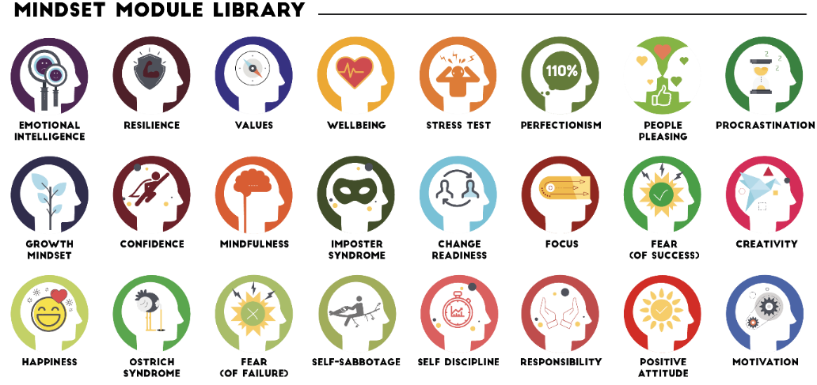
Lessons provides a library of e-learning topics designed to give everyone the capability to coach and covers topics like Coaching for Conversations, for Mindset and for Skills.
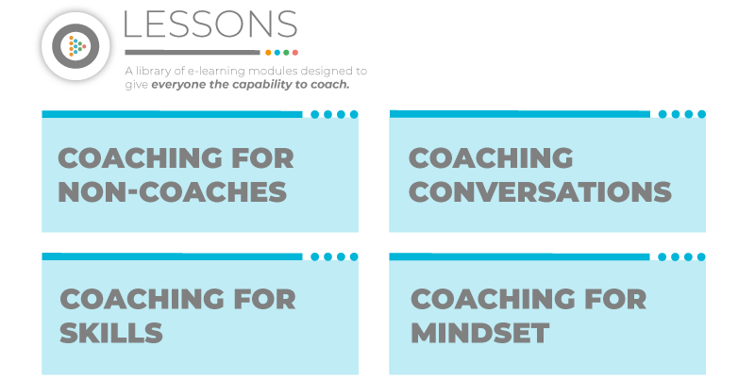
Interested?
If you want to start your coaching journey and develop one of the key skills needed to lead effectively in today’s world, log on to the Coaching Culture Platform http://coachingculture.aston.ac.uk and see what is available to support your development.
Organisational Development also offer Introduction to Coaching and Manager as Coach journeys that work hand in hand with the new platform. Email orgdev@aston.ac.uk for more information or speak to your ODBP.

